**1. SYNOPSIS**

* The E-Vaccine is a web application for to take online slot Booking an efficient manner and no time wasting in queue
* The main objective of E-Vaccine is to efficiently book slot the User thoroughly through a fully automated system that not only saves a lot of time but also gives fast results.
* For users, they book slots according to their convenience and time and there is no queue or .
* This can be used in Government Hospitals as well as in private vaccine center.

**2. PREAMBLE**

2.1 **General Information:-**

**“E-vaccine”** is a website that provides facilities for Users to online slot Booking for vaccine

The website provides a section for users to update themselves

The website provides a section for Hospital to update where hospitals can update their time slots, according to their availability

**Modules included in the projects and description in detail:**

**3.1 User:**

 Interactive user interface

* **3.1.1 Homepage**

In this module, we will display information like Register/login

* **3.1.2 Register**

In which users can register their details. By giving information like Username, Email, and Password.

* **3.1.3 Login**

In which user can login into the site by their Email id and password.

* **3.1.4 Slot availability**

In this module, users can check the time and date for their vaccine slot booking, and book slot for vaccine

* **3.1.5 Profile**

In this module, users can interact with their profile like they can see the Given Name, Address, Email, and contact details. They can also update their profile picture.

* **3.1.6 My Booking**

In which users can their bookings or booking status whether the user can take the vaccine or not.

**3.2 Hospital:**

* **Dashboard**

In this module, the hospital can see how many users can register themself and how many users book slots and how many users can be vaccinated successfully.

* **Appointment**

In this module, the hospital can create a time slot for vaccine by date and they can also update, delete slots.

* **User appointment**

in this module, the hospital can see user appointments in particular own hospitals by filtering date.

**3.2 Admin:**

* **Dashboard**

In this module, the hospital can see how many users can register themself and how many users book slots and how many users can be vaccinated successfully.

* **Hospital**

In this module, the admin can create the hospital's login, and update hospital's information, and also delete Hospital

* **Vaccine**

In this module, the admin can create vaccine details and update vaccine details and also delete vaccine

1. **Statement of the problem:**

**“E-Vaccine”**is a website developed for vaccine slot booking based on time and date constraints. They access the vaccine registration System by entering the e-mail id and password which is added to the database. users can interact with their profile like they can see the Given Name, Address, Email, and contact details. They can also update their profile picture.

The slot booking will start with display hospital name and vaccine details and address, based on user select hospital time slot will display and user can book time slot according to their availability

The final booking will show in my booking and user also check their vaccine status.

**4.1 Objective of the study:**

* The main aim of E-Vaccine is book slot the User thoroughly through a fully automated system that not only saves a lot of time but also gives fast results.

**4.2 Scope of the study:**

* Online Vaccine System is a computerized system that book slot and also saves time. It fully automates the previously manual process of waiting in the queue

**4.3 Methodology:**

I have implemented the agile method for the entire website development life cycle, which is having the following concepts.

**What is Agile Software Development?**

Agile is a time-focused philosophy that allows creating a project incrementally, dividing it into small pieces. One of its main benefits is the ability to adapt and change at any step and to supply only relevant products to the market.

Agile methodologies are an alternative to the waterfall or traditional sequential development

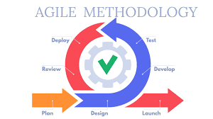

**Some of the agile principles**:

1. People and cooperation are more important than processes and tools

2. The working product is more important than documentation

3. Collaboration with a customer is more important than negotiating the terms of the contract

4. Readiness for change is more important than following the original plan

* An agile company is very flexible quickly adapts to changes, iterates less while implementing faster, and can seize new opportunities as they appear
* High level of interaction between project team members
* The very high customer involvement, while great for the project, may present problems for some customers who simply may not have the time or interest for this type of participation
* Risk of endless product changes.

**5. Feasibility Study:**

The growth and recognition of project management training have changed significantly over the past few years, and they expected these changes to continue and expand. And with the rise of project management comes the need for a feasibility study.

**5.1 What is Feasibility Study?**

As the name implies, a feasibility analysis is used to determine the viability of an idea, such as ensuring a project is legally and technically workable as well as economically justifiable. It tells us whether a project is worth the investment—sometimes, a project may not be doable. There can be many reasons for this, including requiring too many resources, which not only prevents those resources from performing other tasks but also may cost more than an organization would earn back by taking on a project that isn’t profitable.

A well-designed study should offer a historical background of the business or project, such as a description of the product or service, accounting statements, details of operations and management, marketing research and policies, financial data, legal requirements, and tax obligations. Such studies precede technical development and project implementation.

**5.2 Types of Feasibility Study:**

A feasibility analysis evaluates the project’s potential for success; therefore, perceived objectivity is an essential factor in the study's credibility for potential investors and lending institutions. There are five types of feasibility study—separate areas that a feasibility study examines, described below.

**1. Technical Feasibility**

This assessment focuses on the technical resources available to the organization. It helps organizations determine whether the technical resources meet capacity and whether the technical team can convert the ideas into working systems.

Technical feasibility also involves the evaluation of the hardware, software, and other technical requirements of the proposed system. As an exaggerated example, an organization wouldn’t want to try to put Star Trek’s transporters in their building—currently, this project is not technically workable.

**2. Economic Feasibility**

This assessment typically involves a cost/ benefits analysis of the project, helping organizations determine the viability, cost, and benefits associated with a project before financial resources are allocated. It also serves as an independent project assessment and enhances project credibility—helping decision-makers determine the positive economic benefits to the organization that the proposed project will provide.

**3. Legal Feasibility**

This assessment investigates whether any aspect of the proposed project conflicts with legal requirements like zoning laws, data protection acts or social media laws. Let’s say an organization wants to construct a new office building in a specific location. A feasibility study might reveal the organization’s ideal location isn’t zoned for that type of business. That organization has just saved considerable time and effort by learning that their project was not feasible right from the beginning.

**4. Operational Feasibility**

This assessment involves undertaking a study to analyse and determine whether—and how well—the organization’s needs can be met by completing the project. Operational feasibility studies also examine how a project plan satisfies the requirements identified in the requirements analysis phase of system development.

**5. Scheduling Feasibility**

This assessment is the most important for project success; after all, a project will fail if not completed on time. In scheduling feasibility, an organization estimates how much time the project will take to complete.

**6. REVIEW OF LITERATURE**

**6.1 Technology Used:**

* **Laravel**

Laravel is a [free](https://en.wikipedia.org/wiki/Free_software" \o "Free software), open-source [PHP](https://en.wikipedia.org/wiki/PHP" \o "PHP) [web framework](https://en.wikipedia.org/wiki/Web_framework" \o "Web framework), created by Taylor Otwell and intended for the development of web applications following the [model–view–controller](https://en.wikipedia.org/wiki/Model%E2%80%93view%E2%80%93controller) (MVC) [architectural pattern](https://en.wikipedia.org/wiki/Architectural_pattern" \o "Architectural pattern) and based on [Symphony](https://en.wikipedia.org/wiki/Symfony" \o "Symfony). Some of the features of Laravel are a modular [packaging system](https://en.wikipedia.org/wiki/Application-level_package_manager" \o "Application-level package manager) with a dedicated dependency manager, different ways for accessing [relational databases](https://en.wikipedia.org/wiki/Relational_database" \o "Relational database), utilities that aid in [application deployment](https://en.wikipedia.org/wiki/Application_deployment" \o "Application deployment) and maintenance, and its orientation toward [syntactic sugar](https://en.wikipedia.org/wiki/Syntactic_sugar" \o "Model–view–controller).

**6.2 Language Used:**

* **PHP**
* The name PHP stands for Hypertext Pre-processor and denotes a server-side scripting language, which suggests that applications written thereon run on web servers and don’t depend upon the online browser. Syntax of PHP language is analogous to C language. It is created by Rasmus Lerdorf and it appeared in 1995. PHP is being widely utilized in developing web applications and become one among main languages for developers to make new applications.
* Leading social networking sites like Facebook and reputed organizations like Harvard University are both supported PHP which makes PHP popular and increases its credibility.
* However, over years, its area of use has shifted, and nowadays PHP coding language is ranked among simplest and hottest programming tools for web development thanks to its many virtues which can be main target of this text. It’s considered a really effective technology that gives a convenient development process with many additional tools to assist it. In fact, consistent with recognition of programming language Index (PYPL), PHP is that the fifth hottest coding language within world.
* **PHP** is getting used widely in developing web-based and other applications across all domains. for a few of technology supported which PHP applications are developed listed below :
* Content Management System.
* Web-based applications and development of sites.
* E-commerce websites and applications.
* Data Analytics and Representation.
* Processing of Images.
* Graphical interface design based applications.
* Developing the features of Flash.

**Advantages of PHP:** 

* Most important advantage of PHP is that it’s open source and freed from cost. It are often downloaded anywhere and readily available to use for event of web applications.
* It is platform independent. PHP based applications can run on any OS like UNIX, Linux and windows, etc.
* Application can easily be loaded which are based on PHP and connected to database. It’s mainly used due to its faster rate of loading over slow internet and speed than another programming language.
* It has less learning curve, because it is straightforward and straightforward to use. If a private knows C programming can easily work on PHP.
* It is more stable from a few years with assistance of providing continuous support to various versions.
* It helps in reusing an equivalent code and no got to write lengthy code and sophisticated structure for event of web applications.
* It helps in managing code easily.
* It has powerful library support to use various function modules for data representation.
* PHP’s built-in database connection modules help in connecting database easily reduce trouble and time for development of web applications and content based sites.

* Popularity of PHP gave rise to various community of developers, a fraction of which may be potential candidates for hire.

**6.3 Architecture Used:**

* **MVC:**
* The **Model View Controller** (MVC) design pattern specifies that an application consists of a data model, presentation information, and control information. The pattern requires that each of these is separated into different objects.

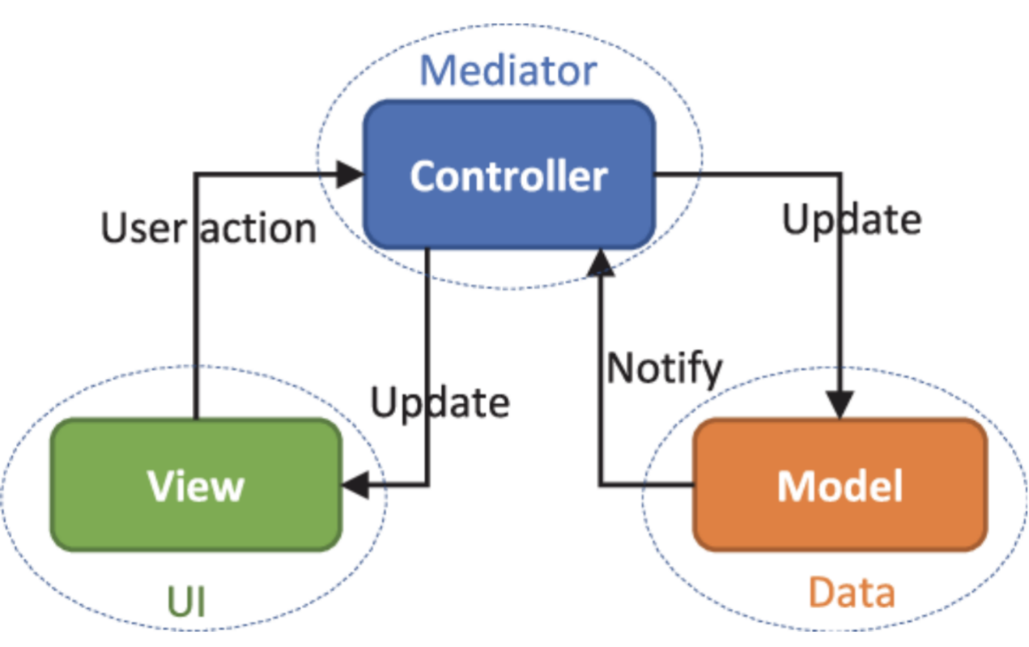

* The Model contains only the pure application data, it contains no logic describing how to present the data to a user.
* The View presents the model’s data to the user. The view knows how to access the model’s data, but it does not know what this data means or what the user can do to manipulate it.
* The Controller exists between the view and the model. It listens to events triggered by the view (or another external source) and executes the appropriate reaction to these events. In most cases, the reaction is to call a method on the model. Since the view and the model are connected through a notification mechanism, the result of this action is then automatically reflected in the view.

**7. TECHNICAL DESCRIPTION**

* 7.1 Hardware Requirement :-

|  |  |
| --- | --- |
| Pre-processor | Intel Pentium dual core |
| Hard Disk | 500 GB & above |
| RAM | 4 GB & above |

* 7.2 Software Requirement :-

|  |  |
| --- | --- |
| Programming tool | Visual code 1.58.2 |
| Data Storage | MYSQL 8.0.2 |
| Software | composer2.1.5  xampp 2.4.46 |
| Framework | PHP Laravel 8 |
| Modules | Node.js 14.16.0 |

**8. SYSTEM DESIGN AND DEVELOPMENT**

**8.1 Database Design**

* **Database: e-vaccine**
* **Keys:** 
  + **P – Primary key**
  + **F – Foreign key**
  + **U– Unique**

**8.1.1. User**

|  |  |  |  |  |
| --- | --- | --- | --- | --- |
| **Sr.no** | Field_name | Data Type | key | Description |
| **1** | Id | Big int | P | Id is unique and generate automatically | |
| **2** | Name | varchar | - | Store user name | |
| **3** | E mail | varchar | U | Unique email id | |
| **4** | Email_verified at | timestamp | - | Time when email is verified | |
| **5** | Password | Varchar | - | Encoded password | |
| **6** | Role_id | int | - | Role id define user credentials | |
| **7** | Address | Varchar | - | Store address | |
| **8** | Phone_number | Varchar | - | Store contact details | |
| **9** | Image | Varchar | - | User image | |
| **10** | Pin code | varchar | - | Store pin code | |
| **11** | Gender | Varchar | - | User’s Gender | |
| **12** | Remember_token | Varchar | - | Token is given base on the insert | |
| **14** | Created_at | Timestamp | - | Store date when quiz/challenge is generated | |
| **15** | Updated_at | Timestamp | - | Store last date when it is updated | |
| **16** | Vaccine | Varchar | - | Get Vaccine name | |

**8.1.2 password_resets**

|  |  |  |  |  |
| --- | --- | --- | --- | --- |
| **Sr.no** | **Field name** | **Data type** | **Key** | **Description** |
| **1.** | email | varchar(50) | U | Store email |
| **2.** | token | varchar(100) | - | Store token |
| **3.** | created_at | timestamp | - | Store when request is created |

**8.1.3 failed_jobs**

|  |  |  |  |  |
| --- | --- | --- | --- | --- |
| **Sr.no** | **Field name** | **Data type** | **Key** | **Description** |
| **1.** | id | bigint(20) | P | Store id to identify any failure |
| **2.** | uuid | varchar(100) | - | Store uuid |
| **3.** | connection | text | - | Store connection |
| **4.** | queue | text | - | Store queue |
| **5.** | payload | longtext | - | Store payload |
| **6.** | exception | longtext | - | Store exception |
| **7.** | failed_at | timestamp | - | Store time for failed_at |

**8.1.4 Time**

|  |  |  |  |  |
| --- | --- | --- | --- | --- |
| **Sr.no** | **Field_Name** | **Data Type** | **Key** | **Description** |
| **1** | id | Big int | P | Id is unique and generate automatically |
| **2** | Appointment_id | int | - | Appointment id |
| **3** | time | varchar | - | Time slot |
| **4** | status | int | - | Status 0 or 1 |
| **5** | Created_at | Times stamp | - | Store date when quiz/challenge is generated |
| **6** | Updated_at | Times stamp | - | Store last date when it is updated |

**8.1.5 Booking**

|  |  |  |  |  |
| --- | --- | --- | --- | --- |
| **Sr.no** | Field_name | Data Type | key | Description |
| **1** | Id | Big int | P | Id is unique and generate automatically |
| **2** | User_id | int | - | User’s id |
| **3** | Hospital_id | int | - | Hospital’s id |
| **4** | Time | varchar | - | Time slot |
| **5** | Status | int | - | Status 0 or 1 |
| **6** | Created_at | Times stamp | - | Store date when quiz/challenge is generated |
| **7** | Updated_at | Times stamp | - | Store last date when it is updated |
| **8** | date | varchar | - | Date |

**8.1.6 Appointment**

|  |  |  |  |  |
| --- | --- | --- | --- | --- |
| **Sr.no** | **Field_name** | **Data Type** | **Key** | **Description** |
| **1** | Id | Big int | P | Id is unique and generate automatically |
| **2** | User_id | int | - | User’s id |
| **3** | Date | Varchar | - | Date |
| **4** | Created_at | Times stamp | - | Store date when quiz/challenge is generated |
| **5** | Updated_at | Times stamp | - | Store last date when it is updated |

**8.1.7 Vaccine**

|  |  |  |  |  |
| --- | --- | --- | --- | --- |
| **Sr.no** | **Field_name** | **Data Type** | **Key** | **Description** |
| **1** | Id | Big int | P | Id is unique and generate automatically |
| **2** | Vaccine | int | - | Name of vaccine |
| **3** | Created_at | Times stamp | - | Store date when quiz/challenge is generated |
| **4** | Updated_at | Times stamp | - | Store last date when it is updated |

**8.1.8 Role**

|  |  |  |  |  |
| --- | --- | --- | --- | --- |
| **Sr.no** | **Field_Name** | **Data Type** | **Key** | **Description** |
| **1** | Id | Big int | P | Id is unique and generate automatically |
| **2** | Name | varchar | - |  |
| **3** | Created_at | Times stamp | - | Store date when quiz/challenge is generated |
| **4** | Updated_at | Times stamp | - | Store last date when it is updated |

**8.2 Architectural Design:-**

**DFD Diagram-level 0**

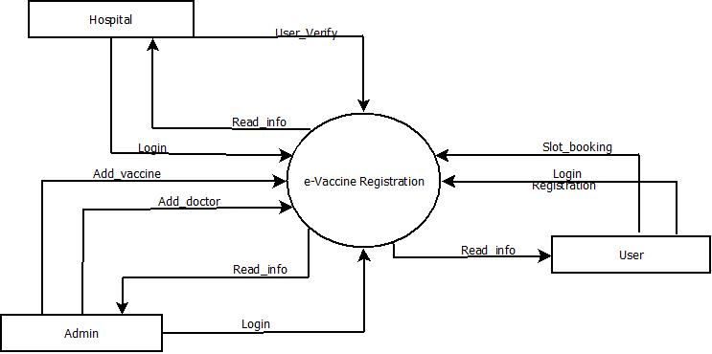

**DFD Diagram level 1**

**DFD level 1**

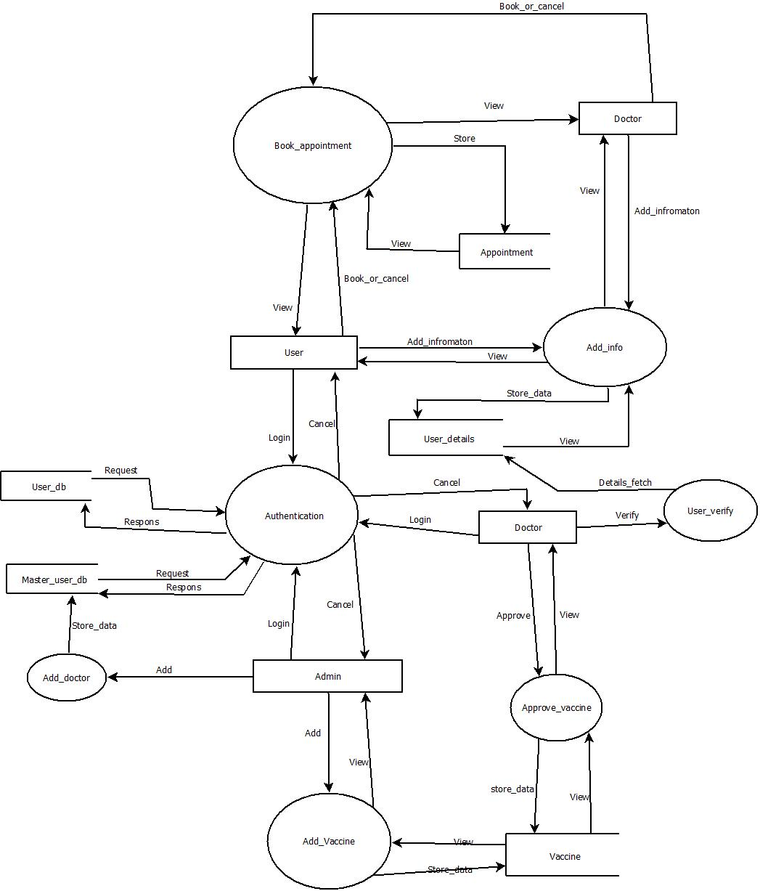

**DFD Diagram level 2**

**8.2.2 User**

**8.2.2.1 User**

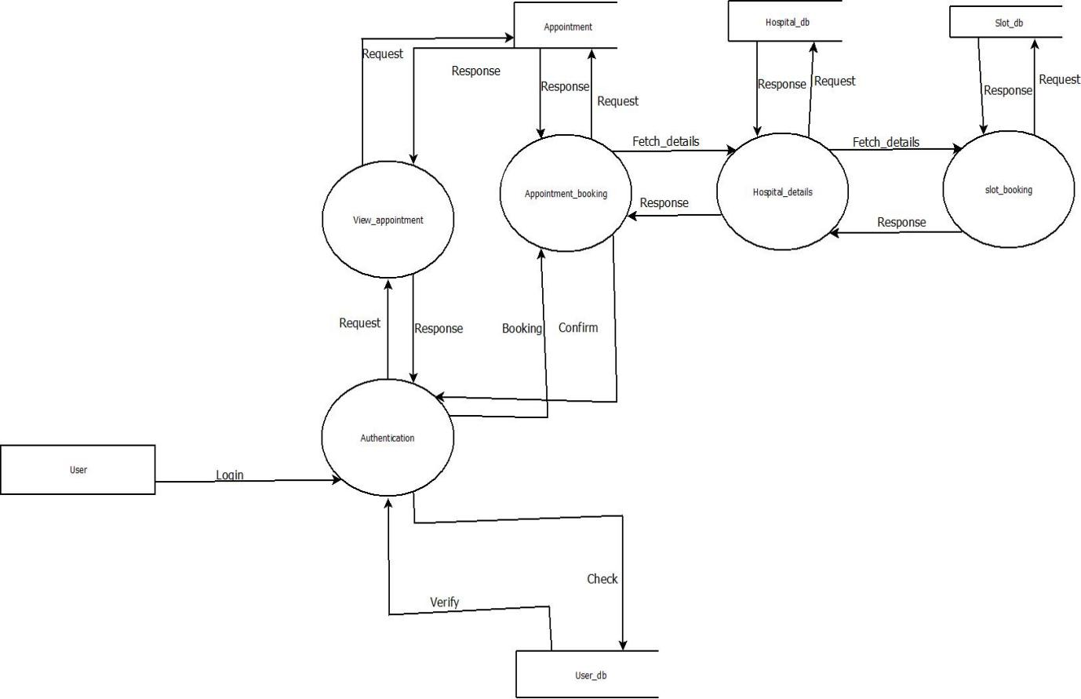

**8.2.2 Admin**

**8.2.2.1 Admin**

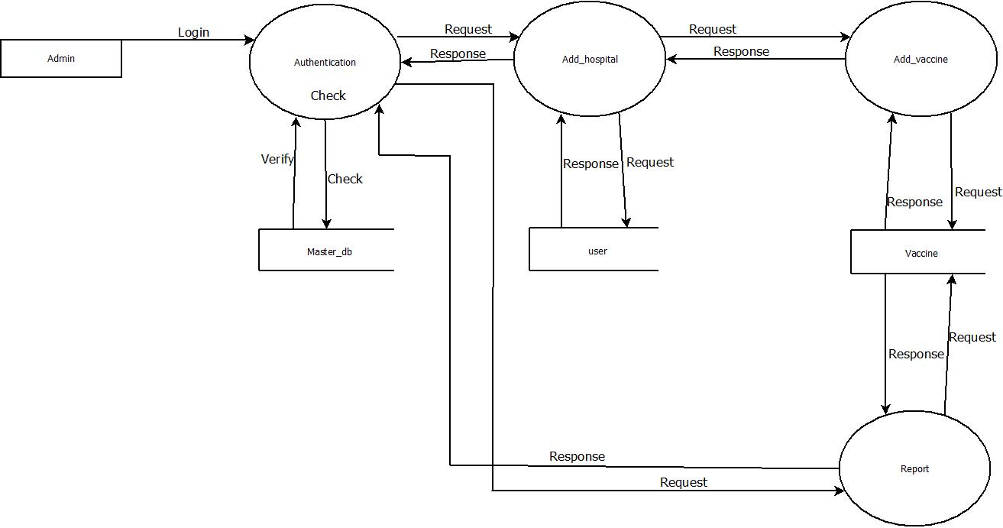

**8.2.2 Hospital**

**8.2.2.1 Hospital**

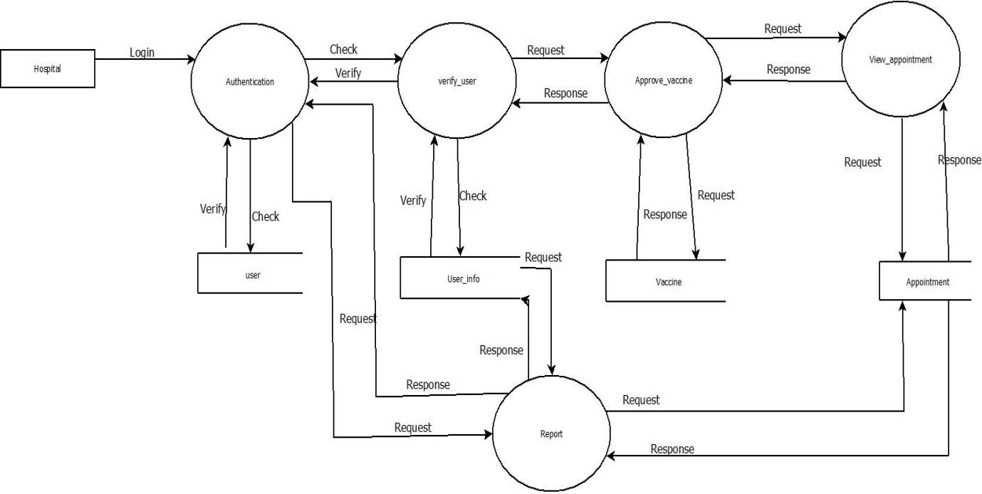

**8.3 Behavioural Modelling**

**8.3.1 Use Case Diagram** 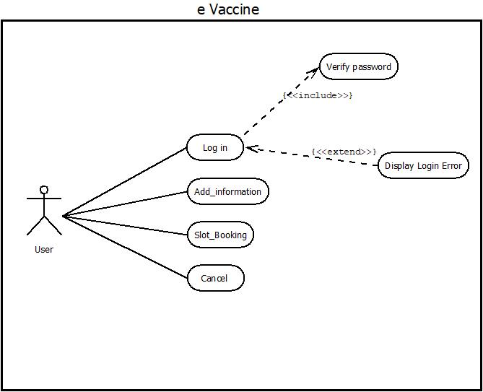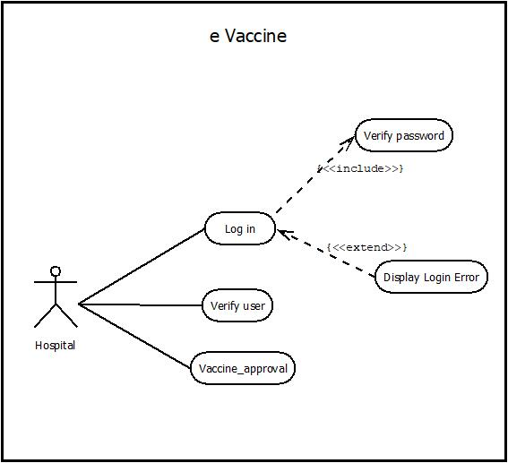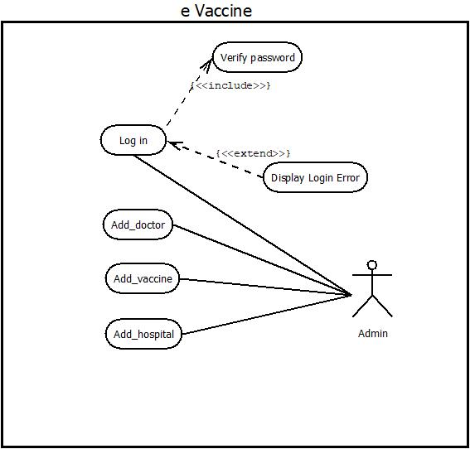

**8.4 UML**

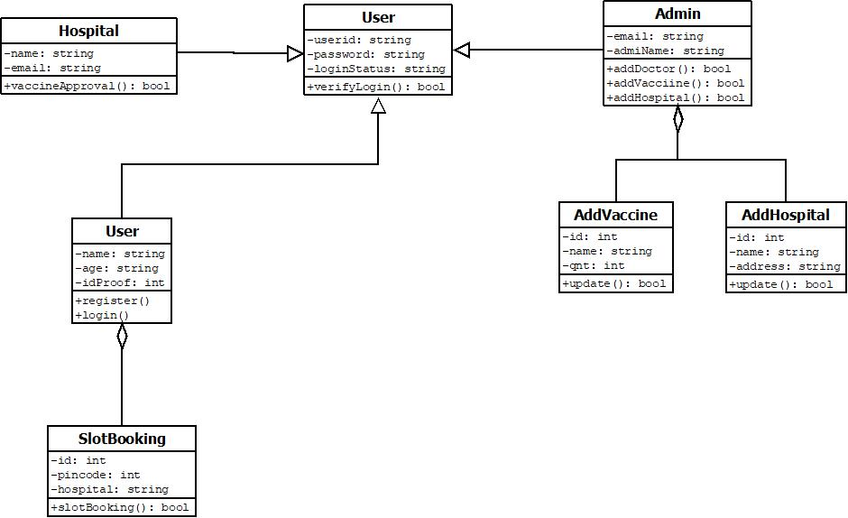

**8.5 Sequence Diagram**

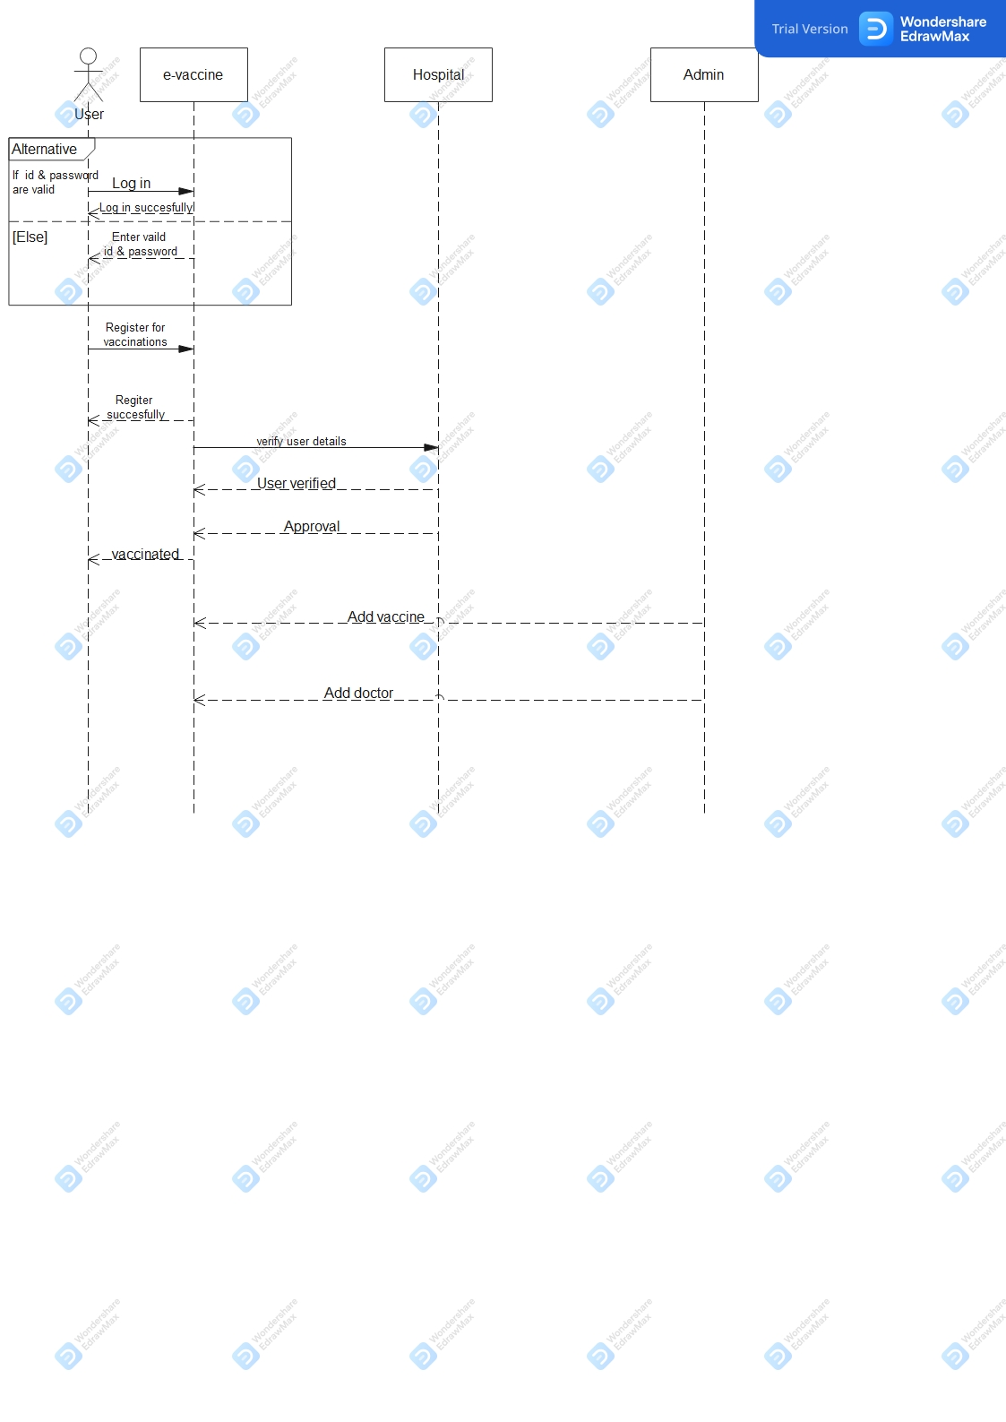

**.6 Activity Diagram**

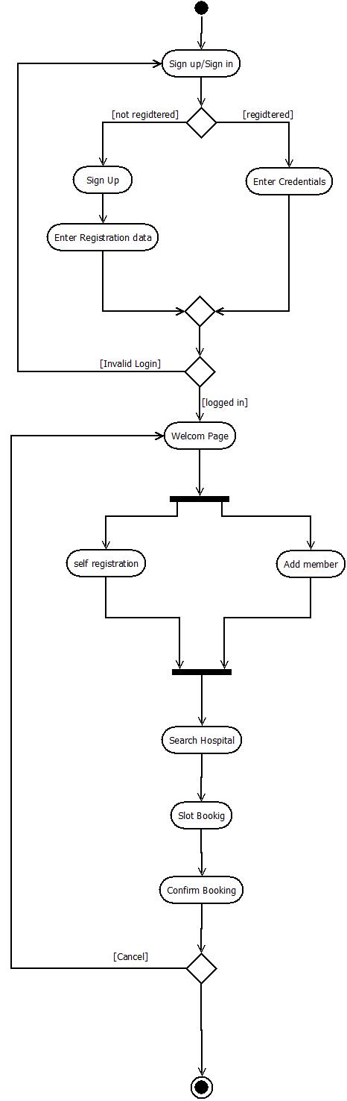

**9 Screen Designing**

**HOME SCREEN**

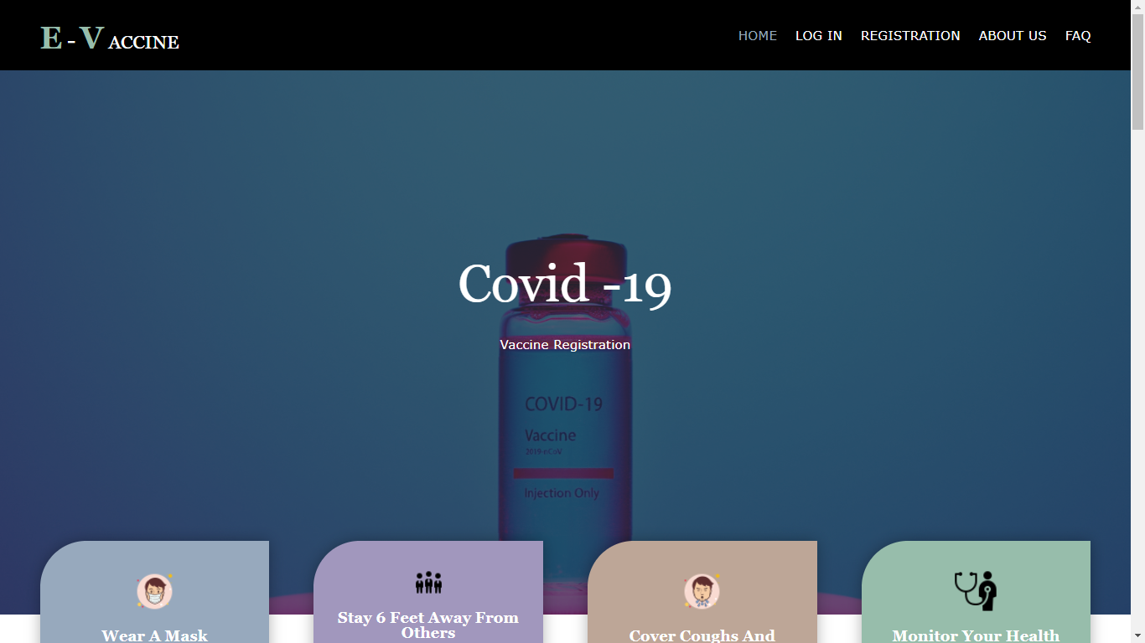

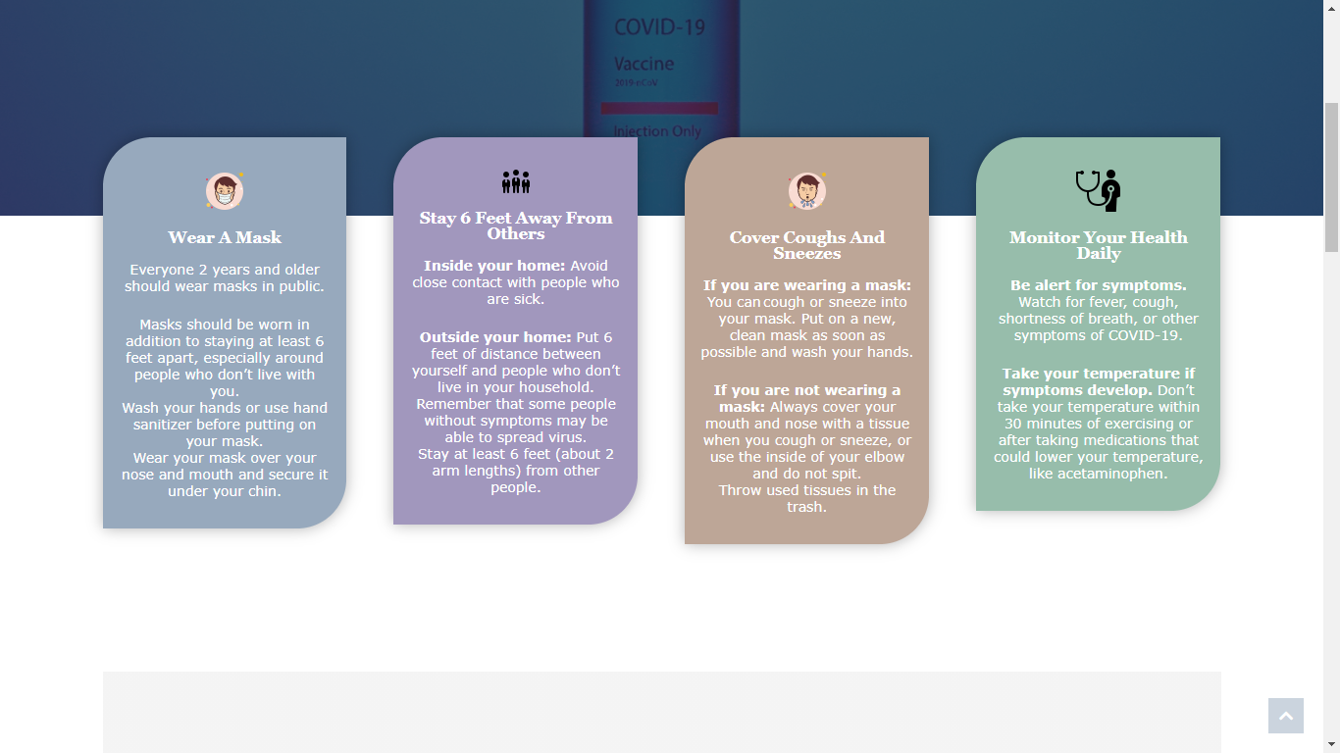

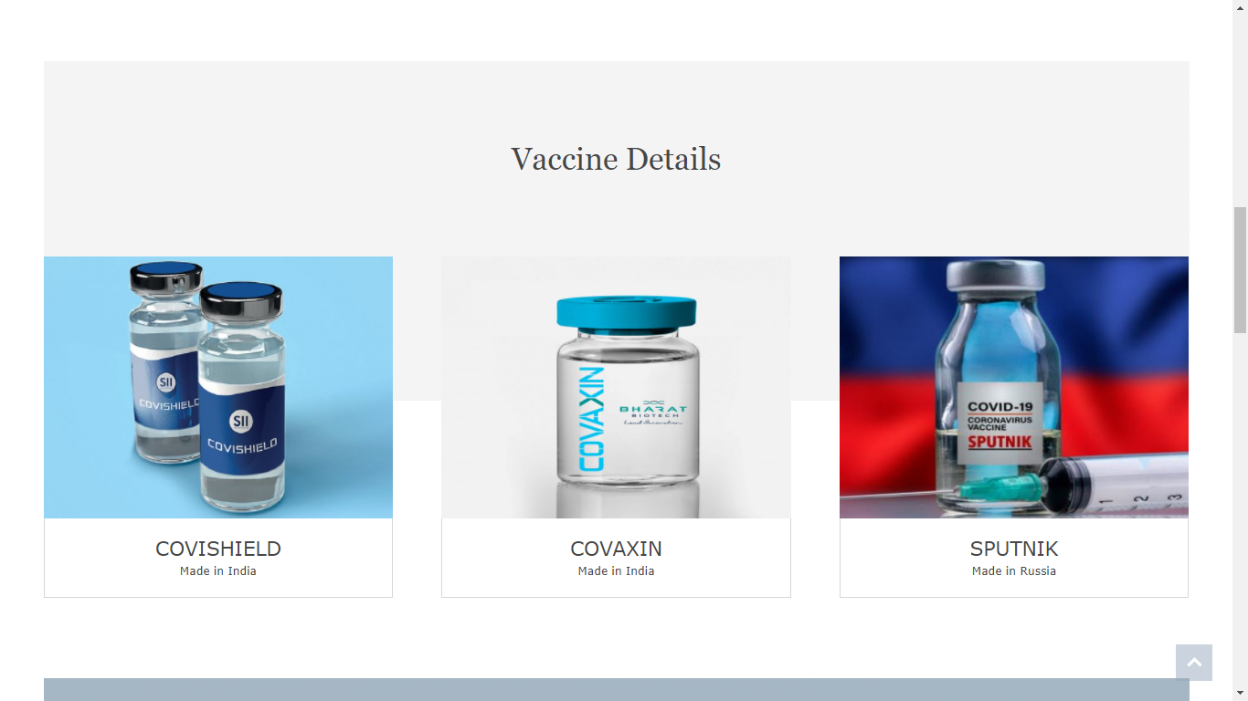

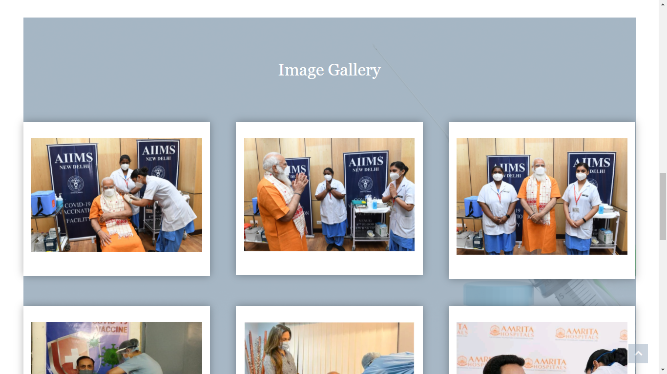

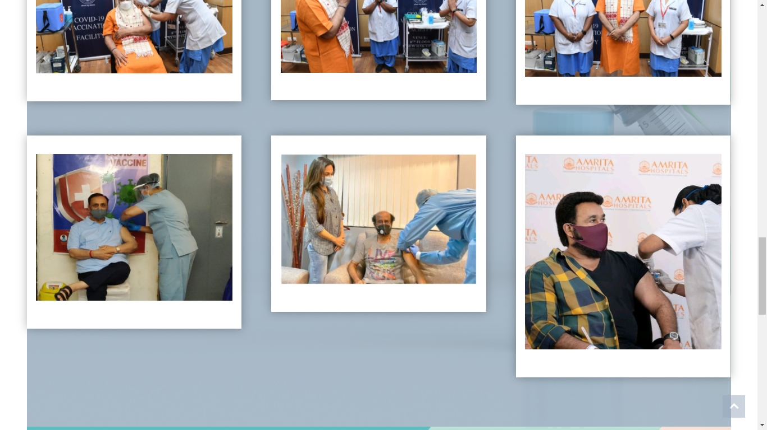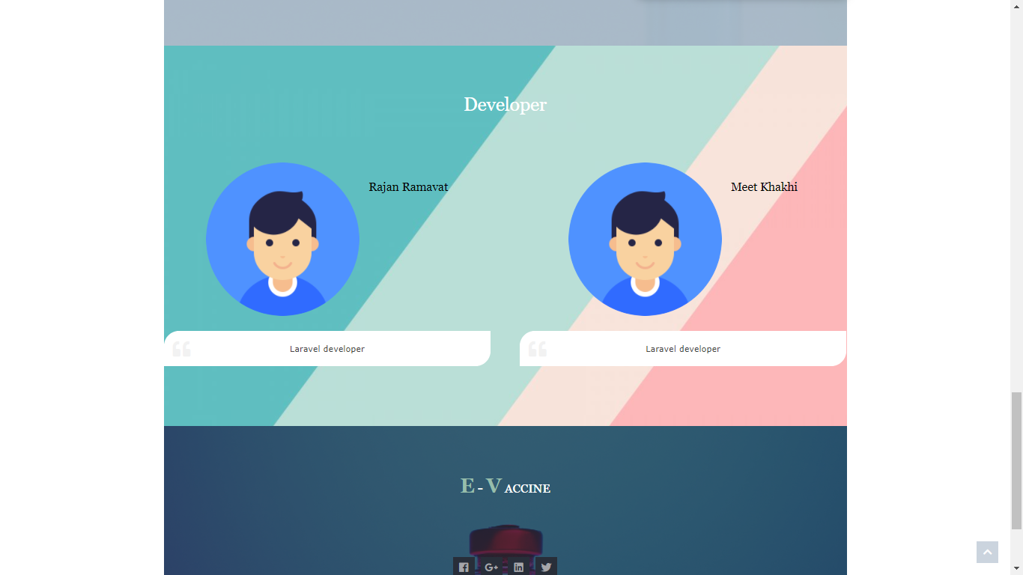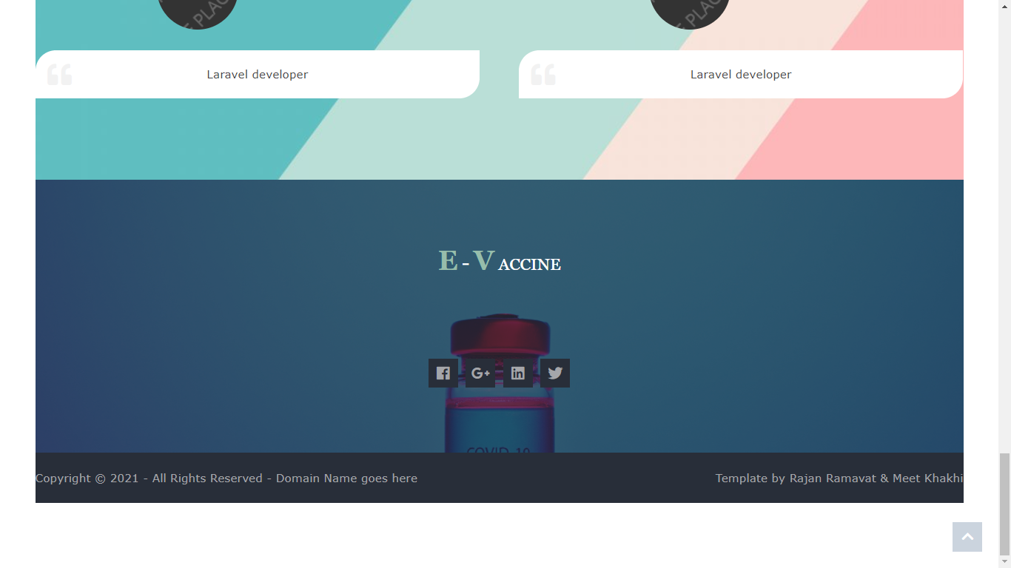

**REGISTRATION**

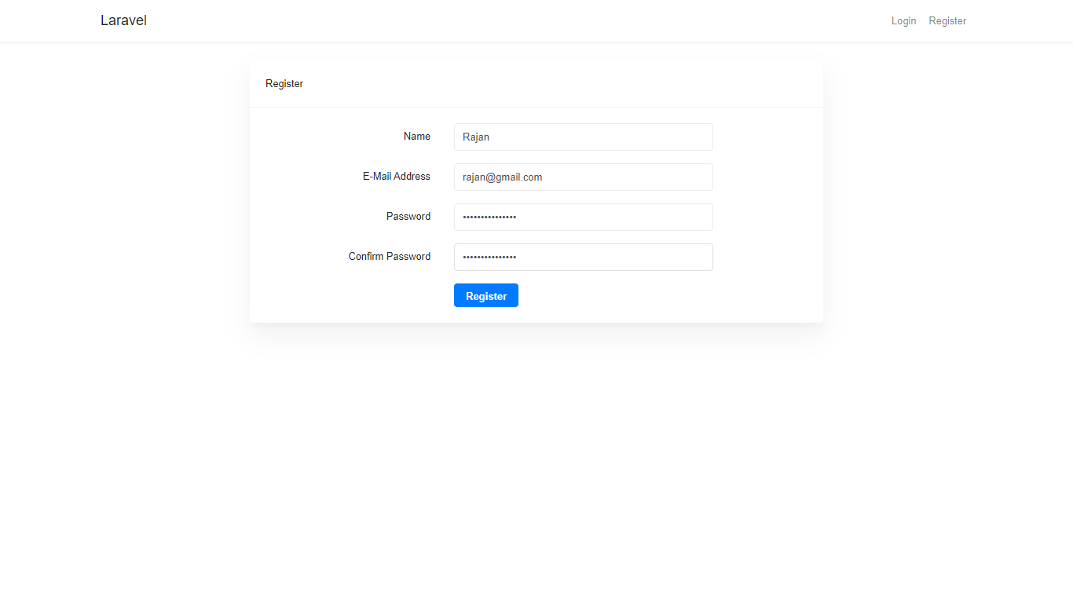

**9.3 LOGIN PAGE**

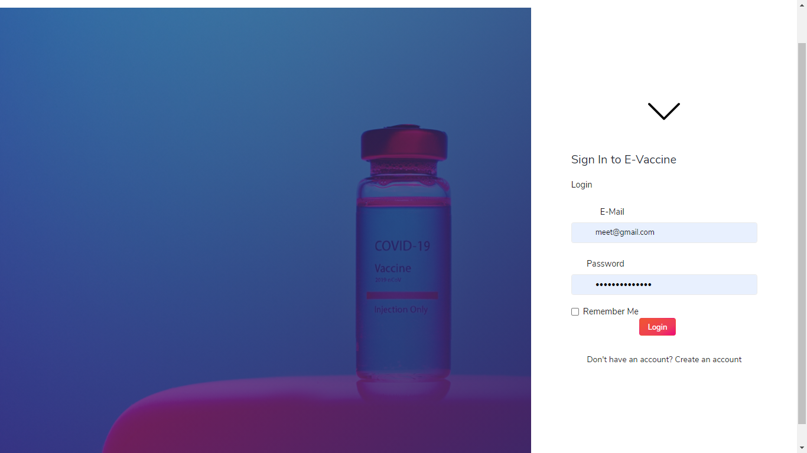

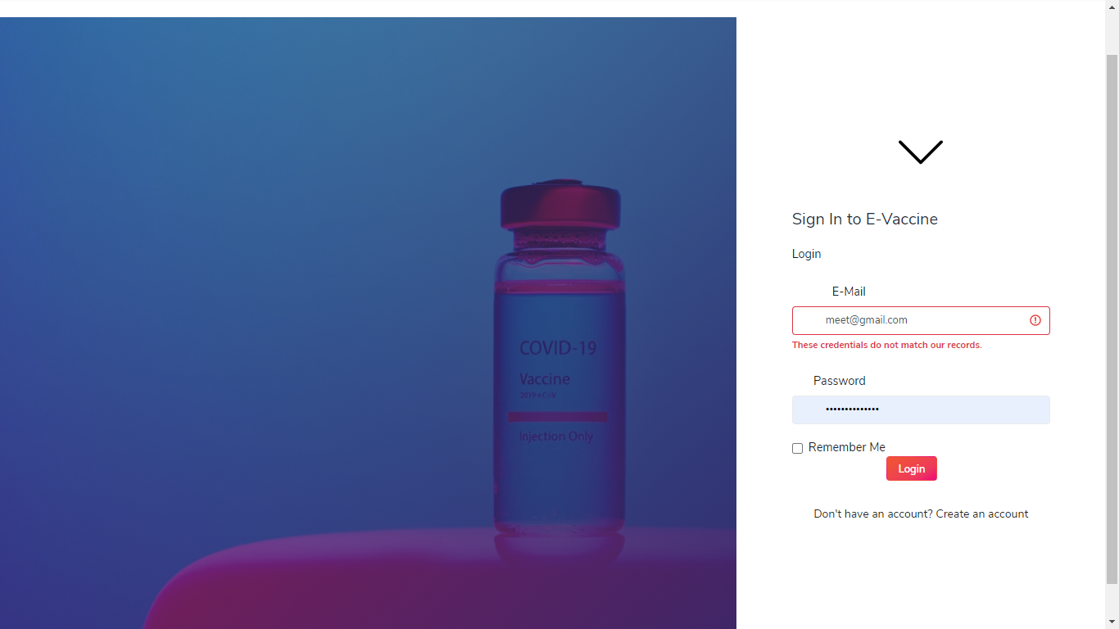**Successful Login:**

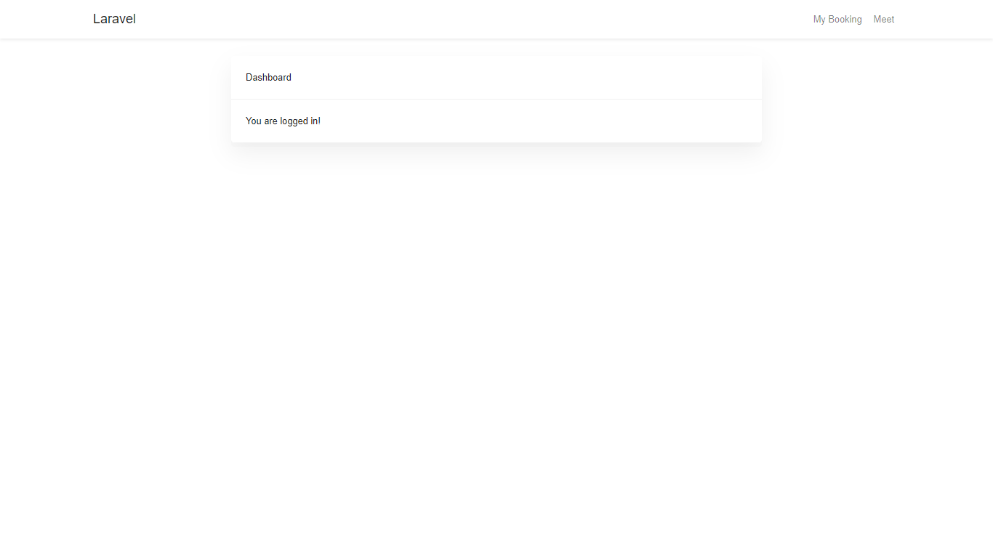

**Update Profile**

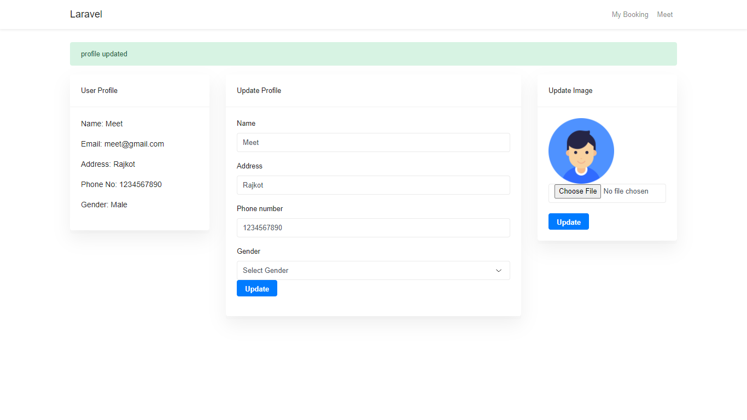

**Slot-Booking** 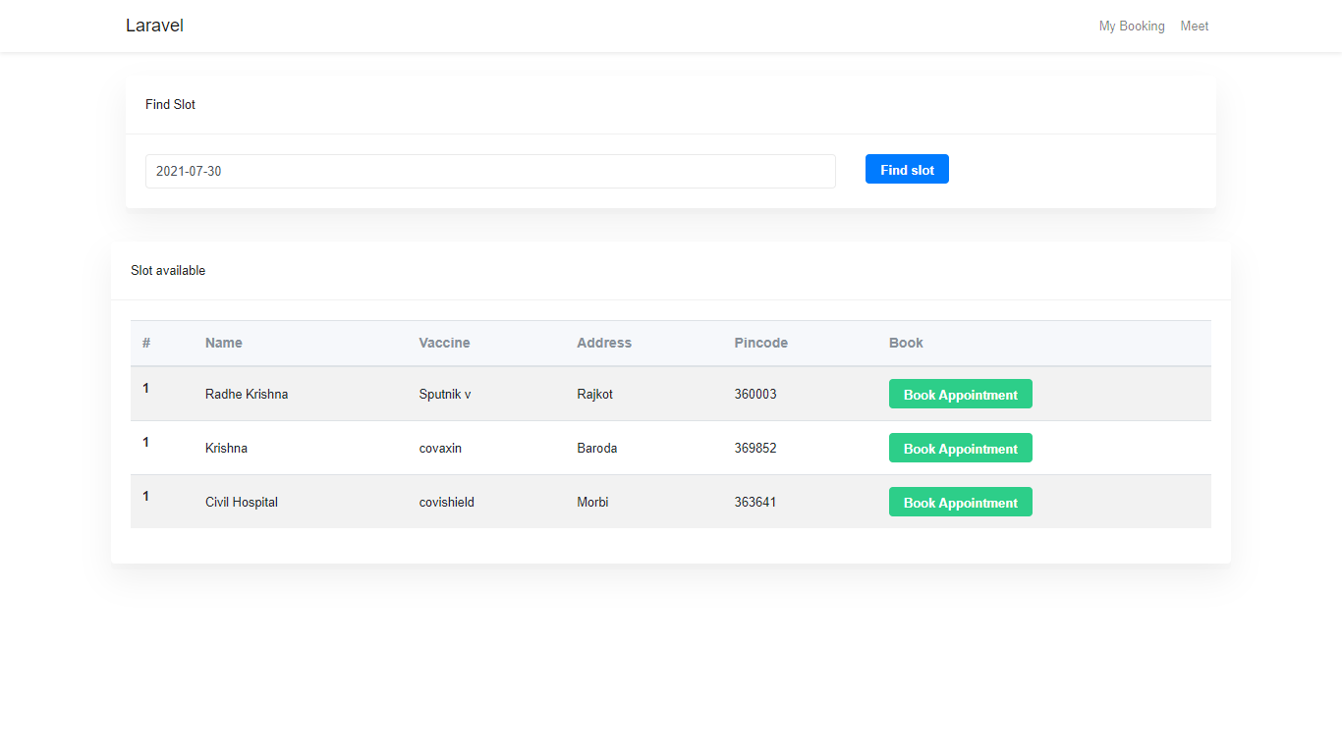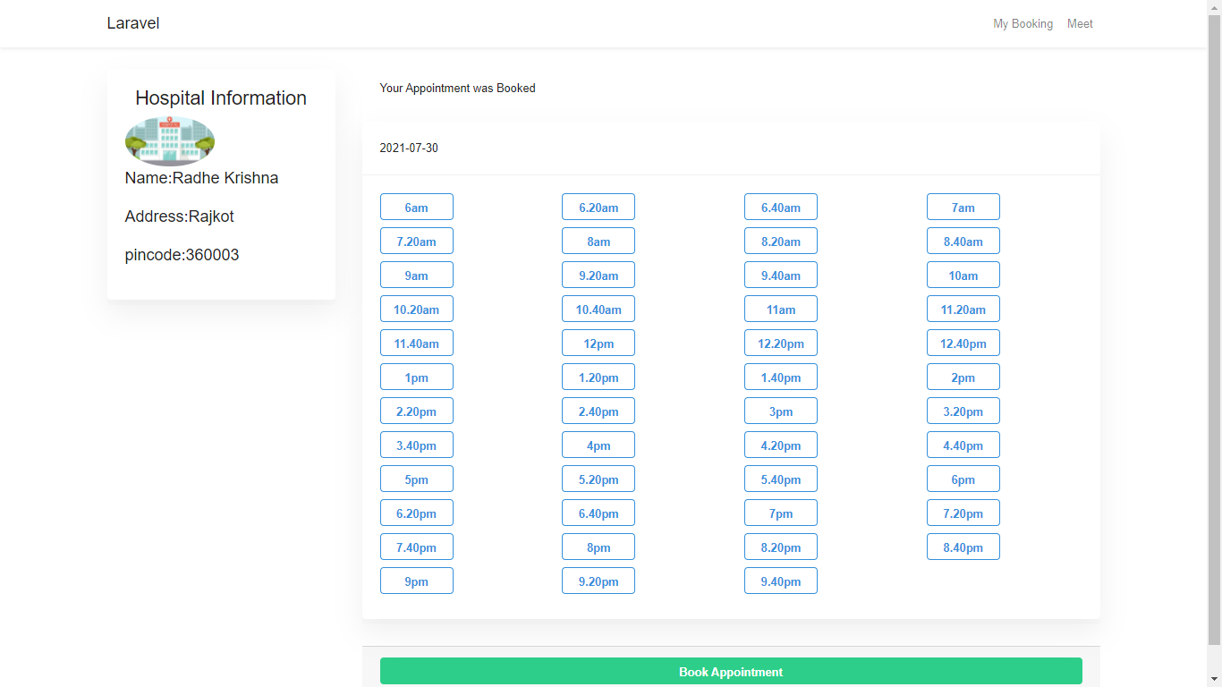

**Booking-status** 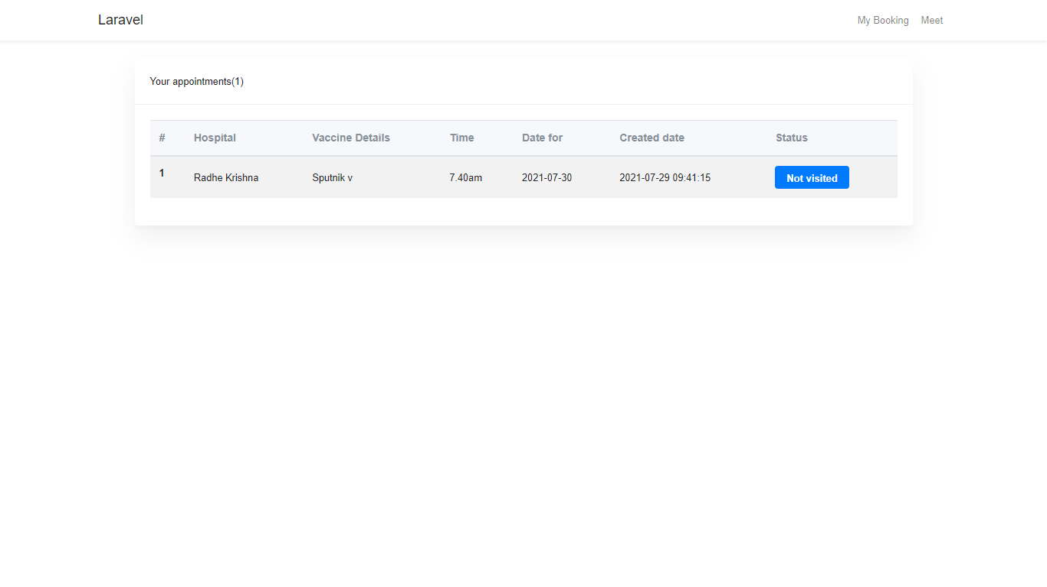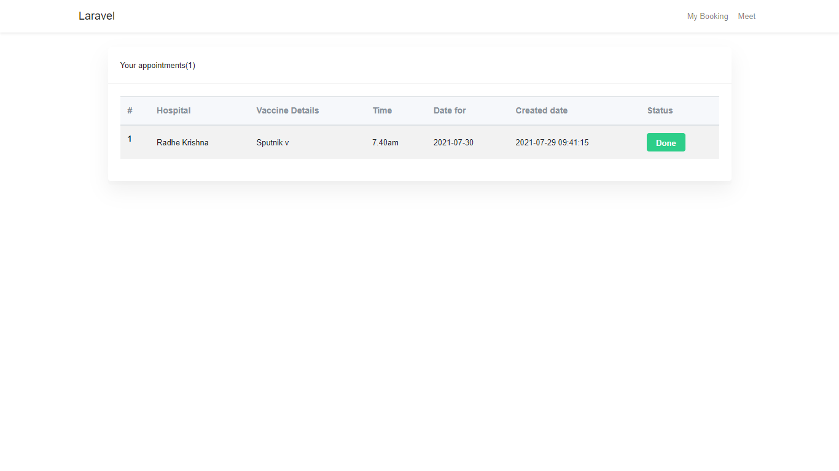

**9.2 Hospital Dashboard**

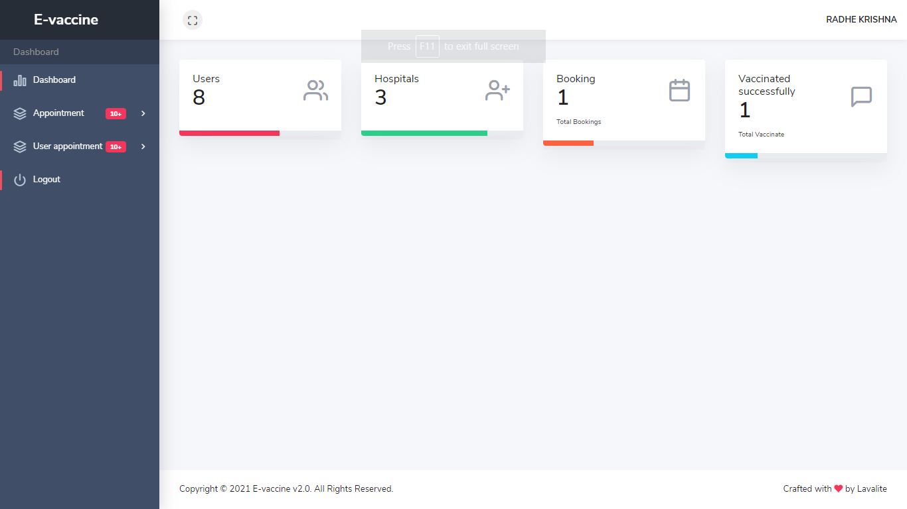

**Create-Appointment** 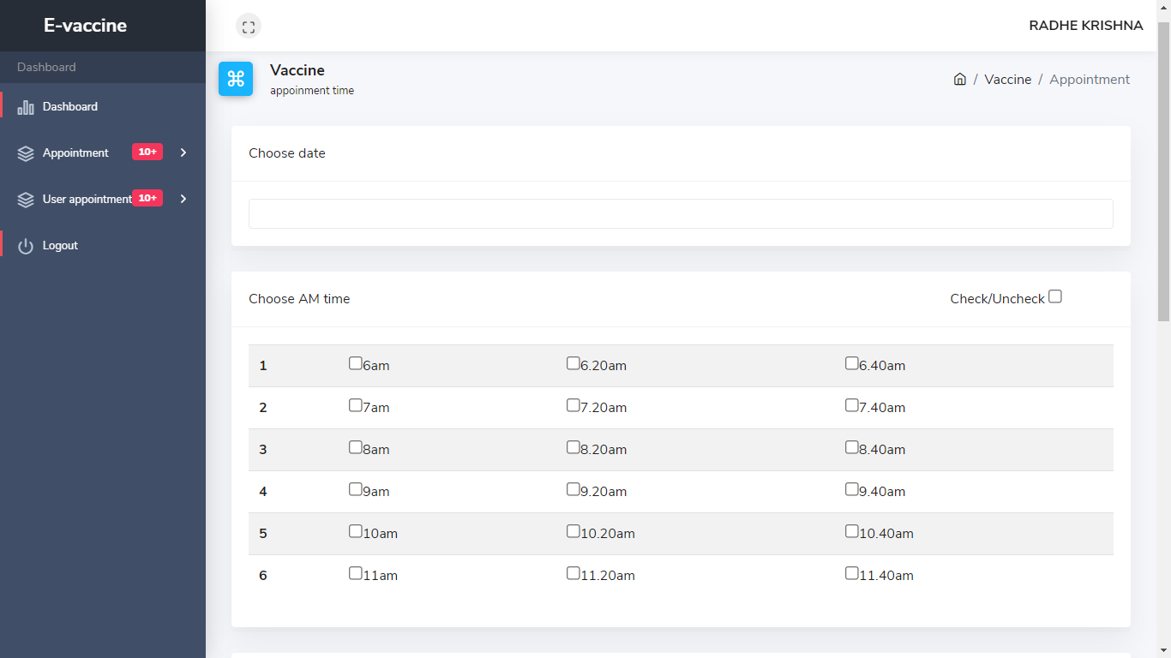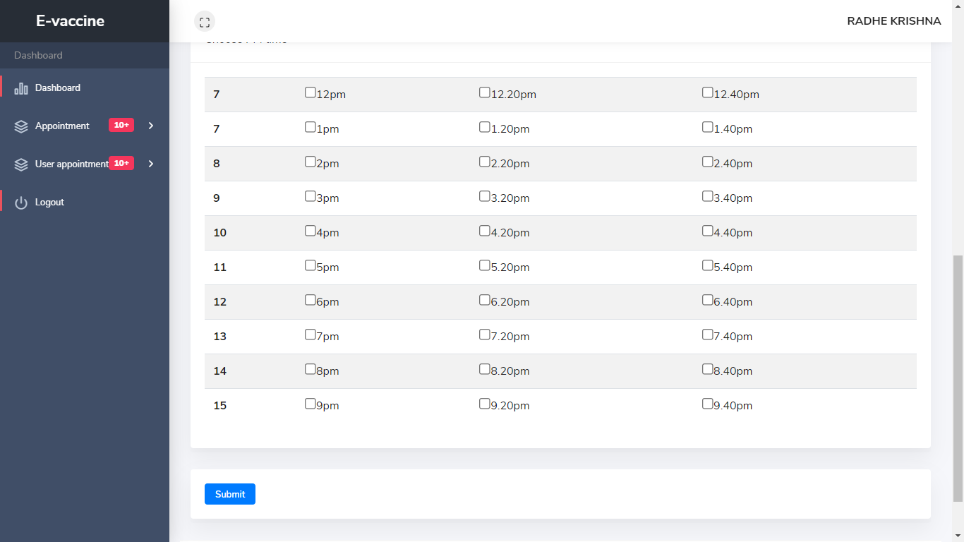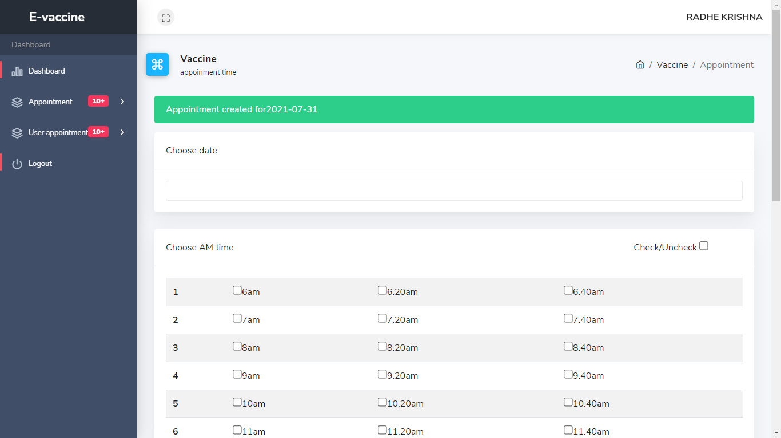

**Show-Appointment**

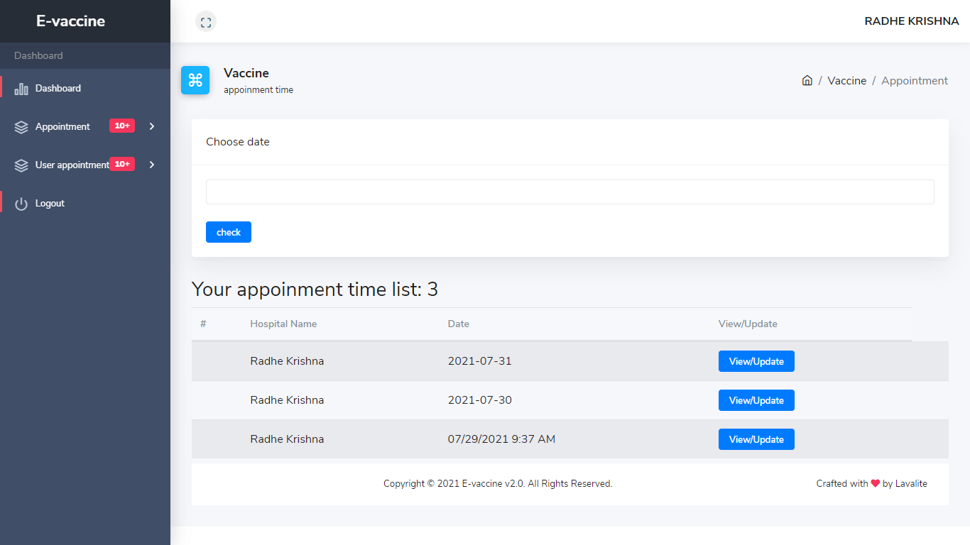

**Update-Appointment**

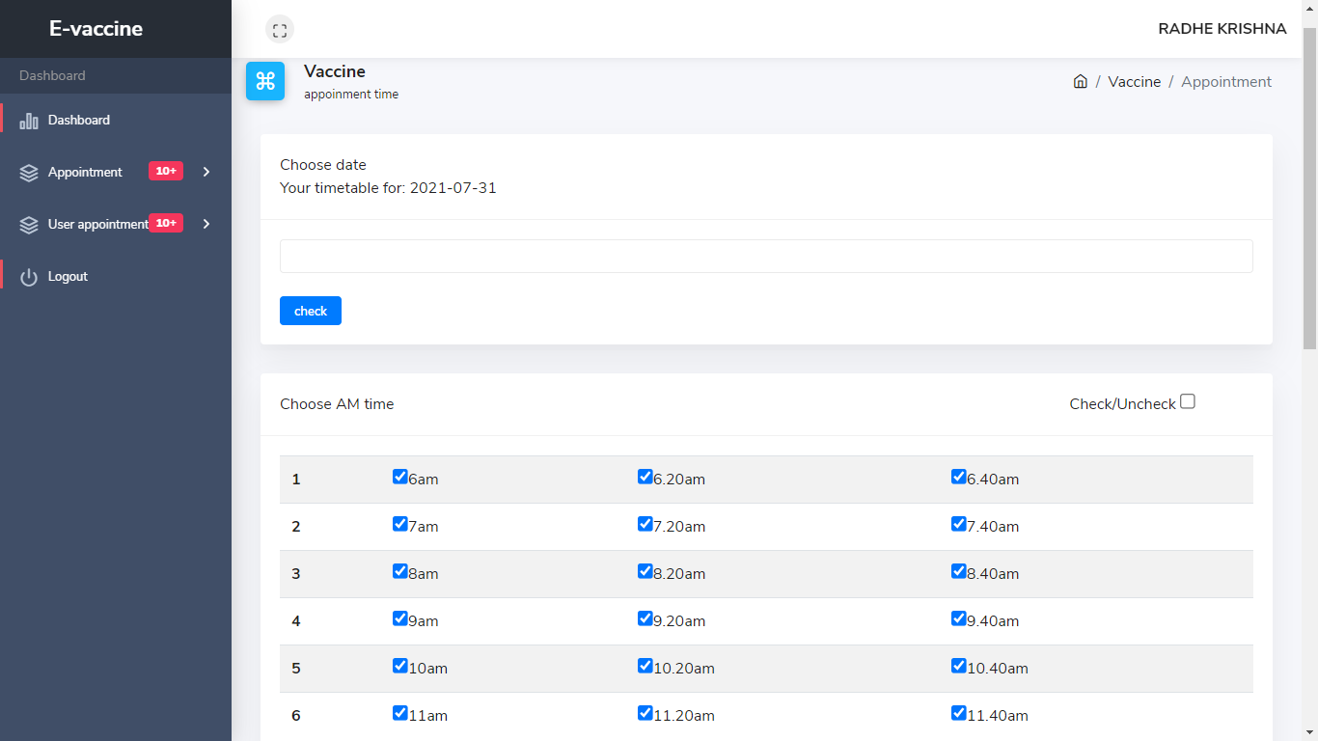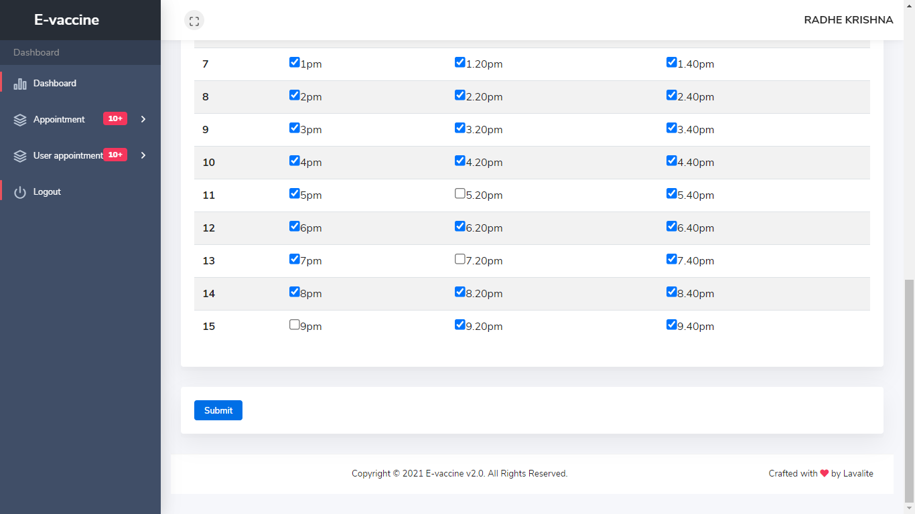

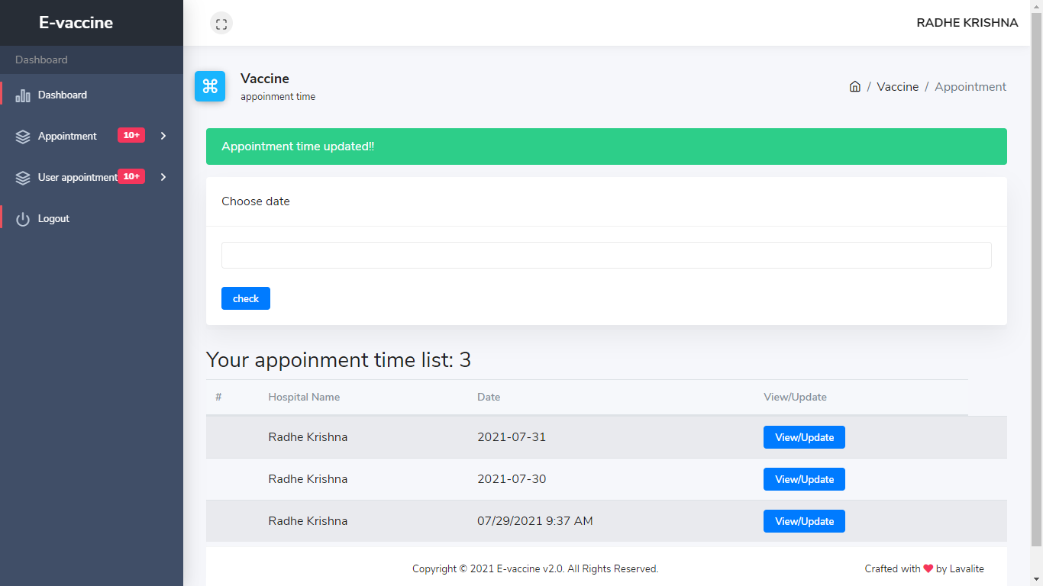

**Show-User-Appointment** 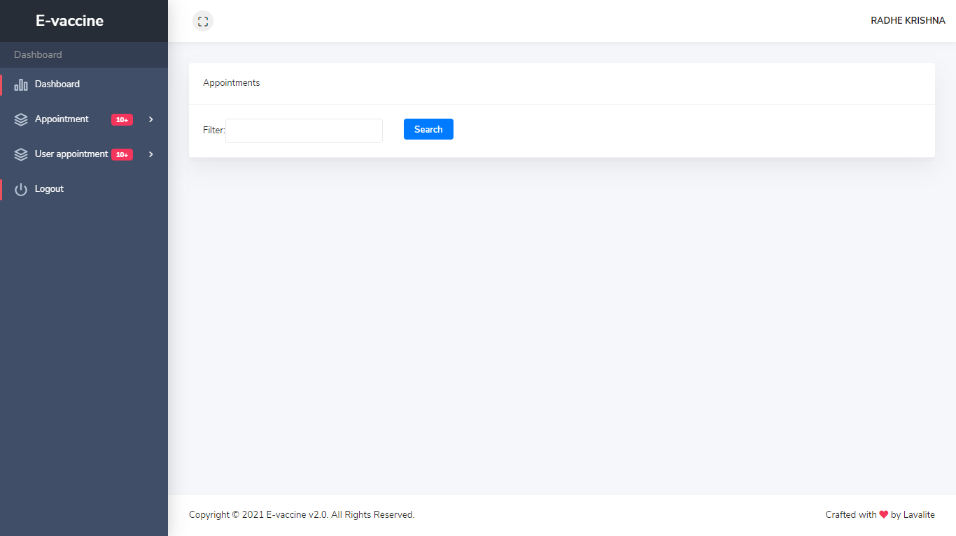

**Update-user-status** 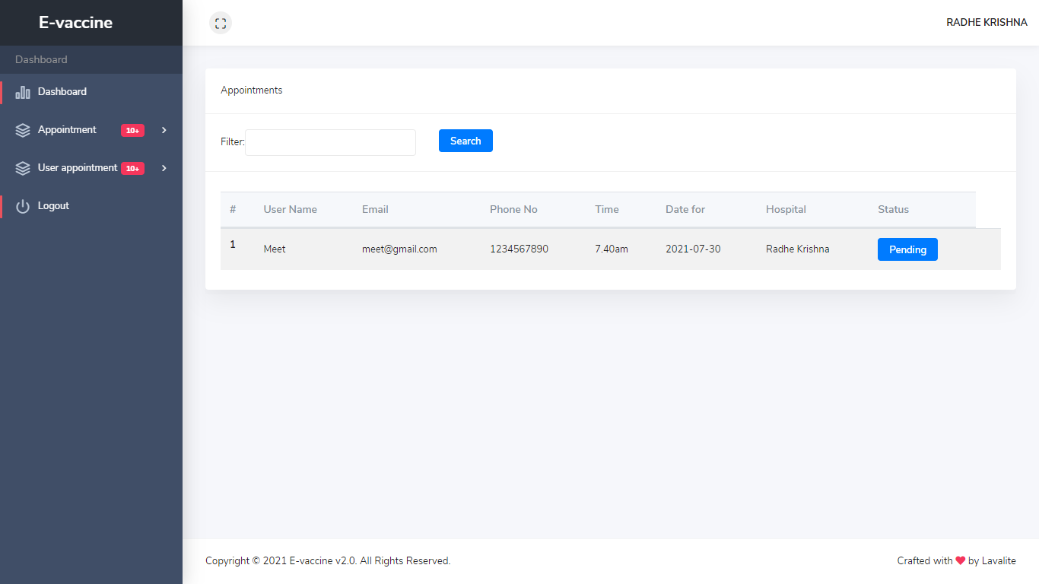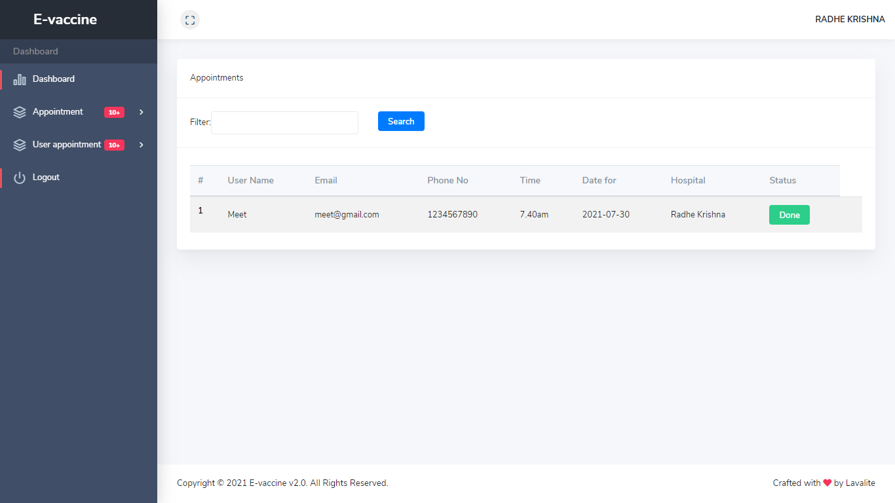

**9.3Admin-Dashboard**

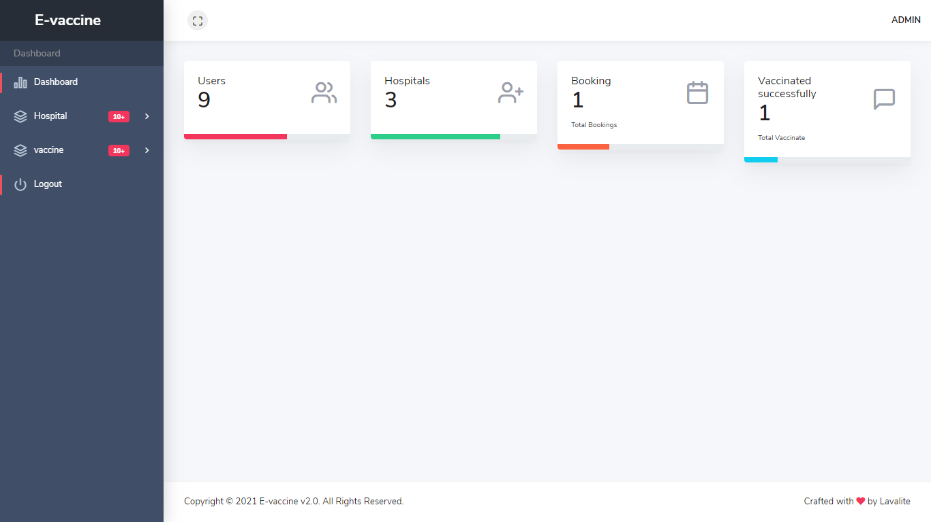

**Add-Hospital**

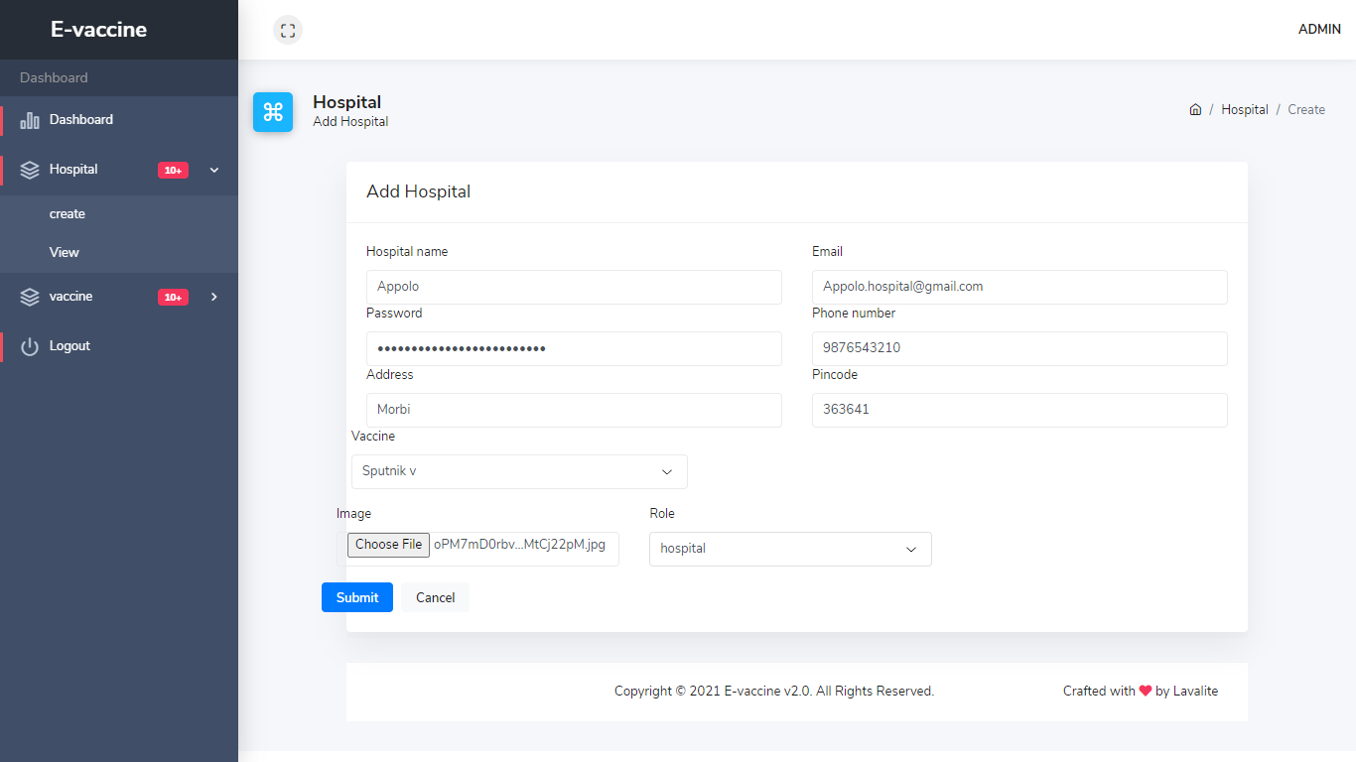

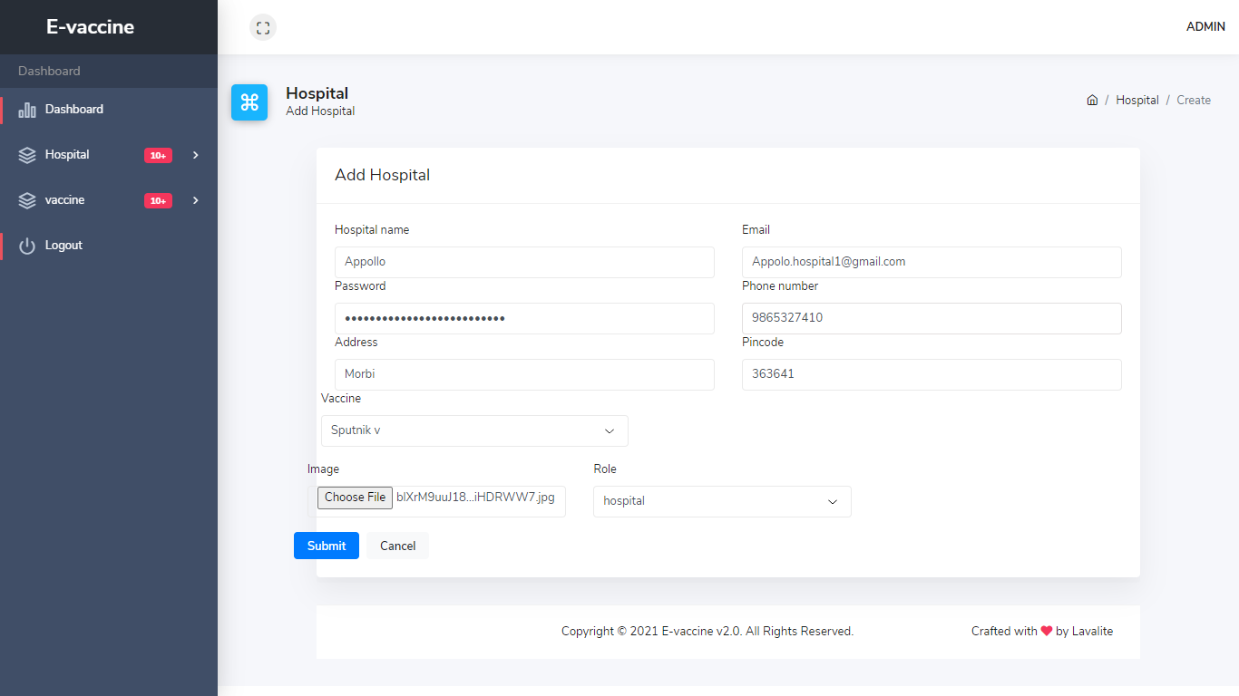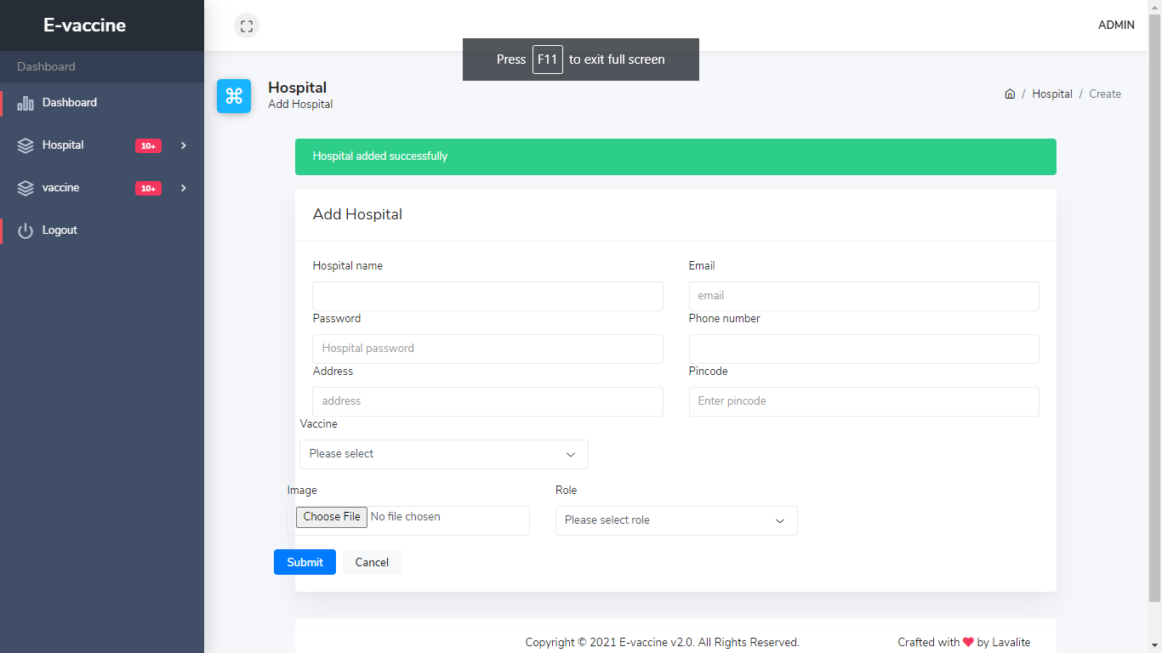

**View-Hospital**

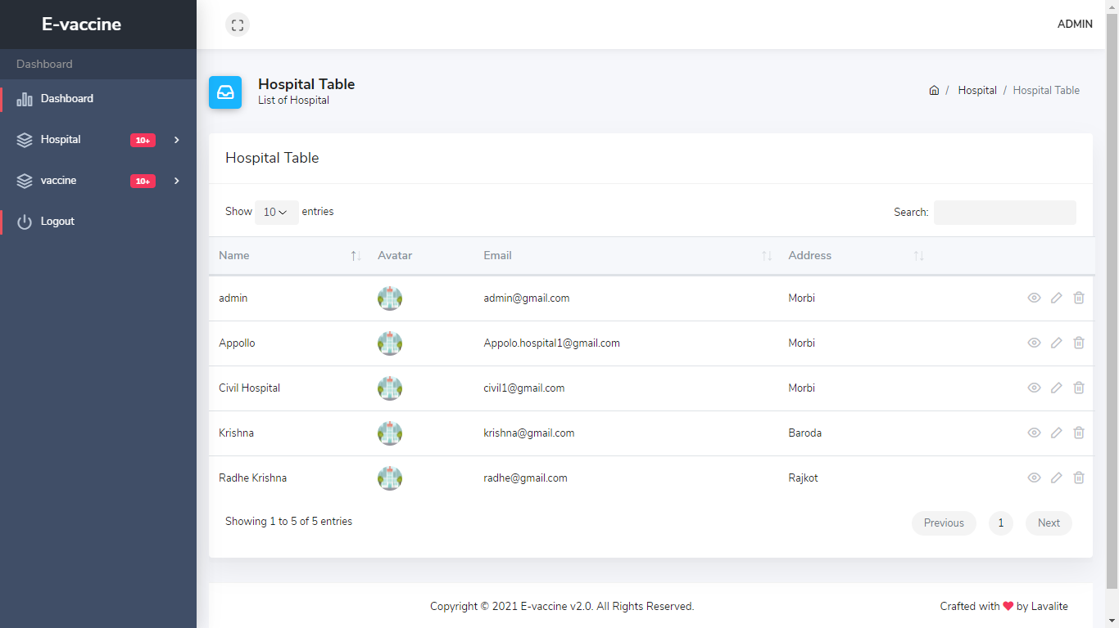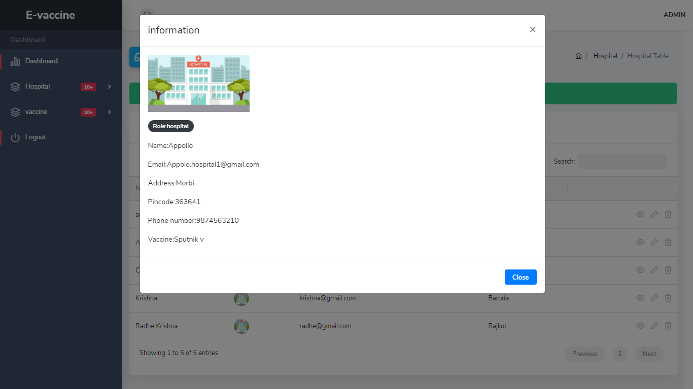

**Update-Hospital**

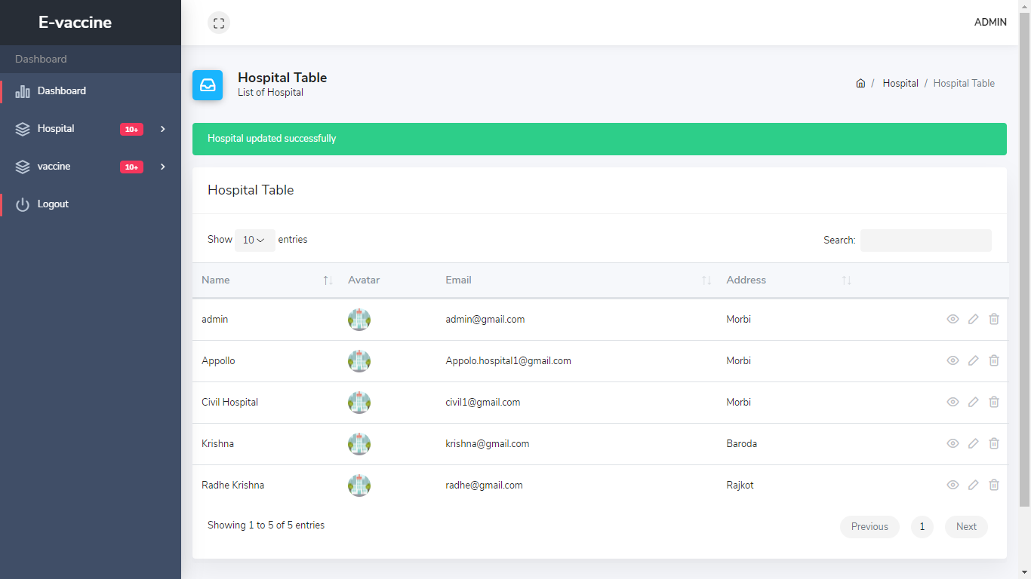

**Delete-Hospital**

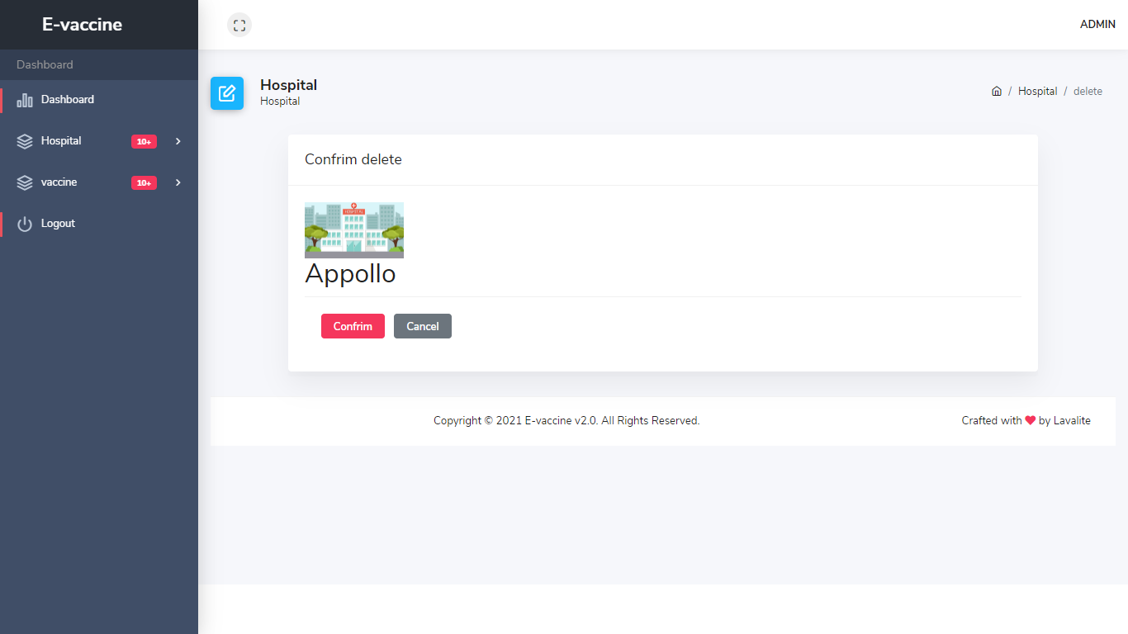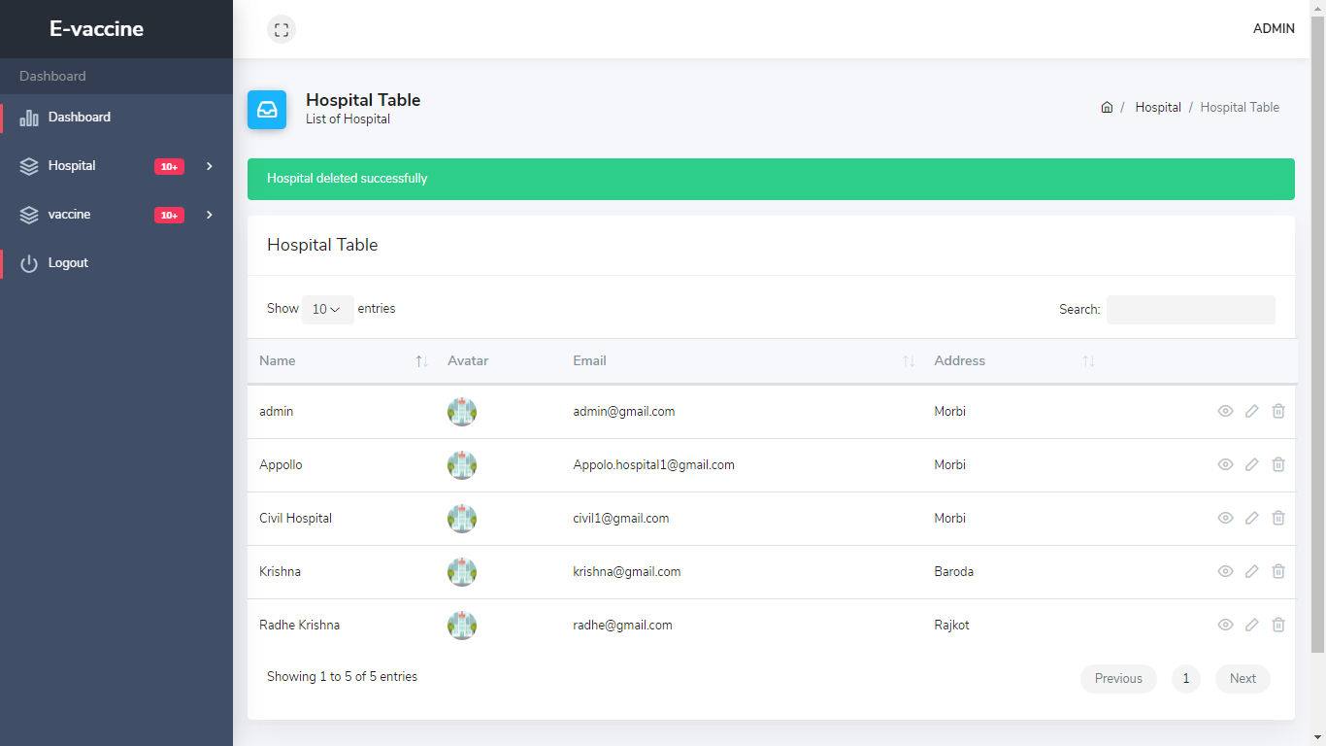

**Add-Vaccine** 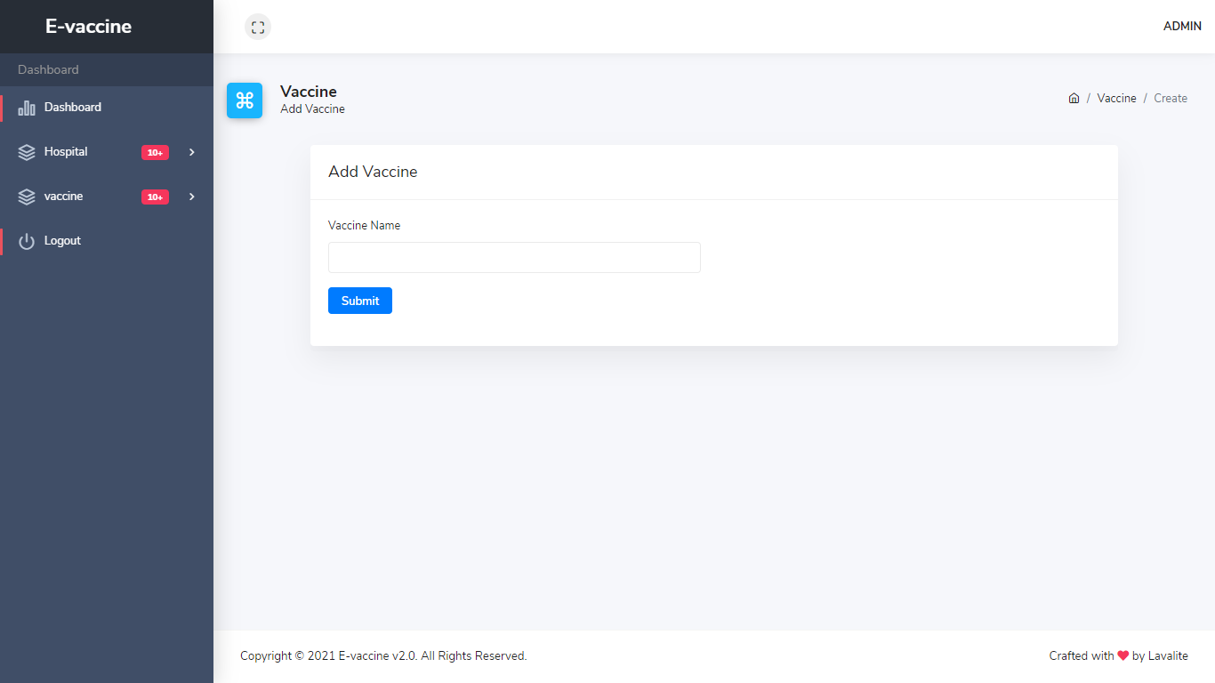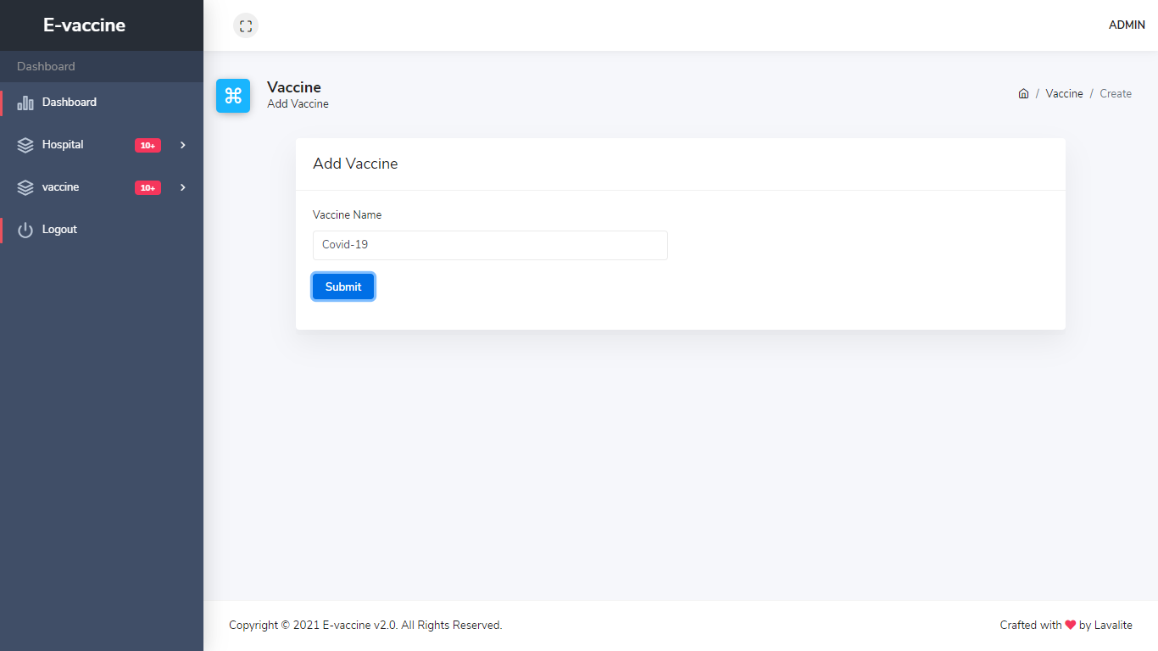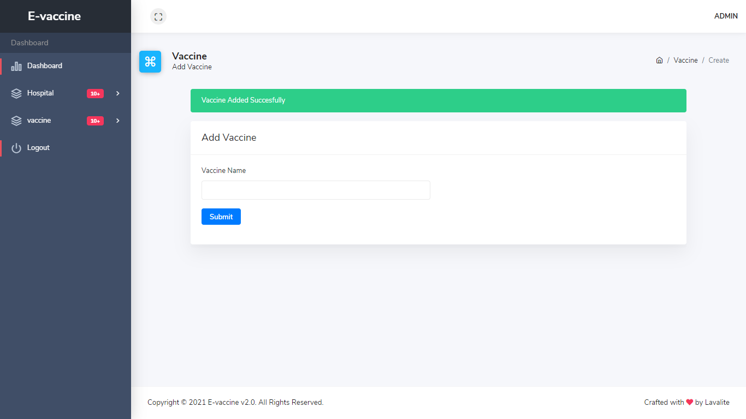

**View-Vaccine** 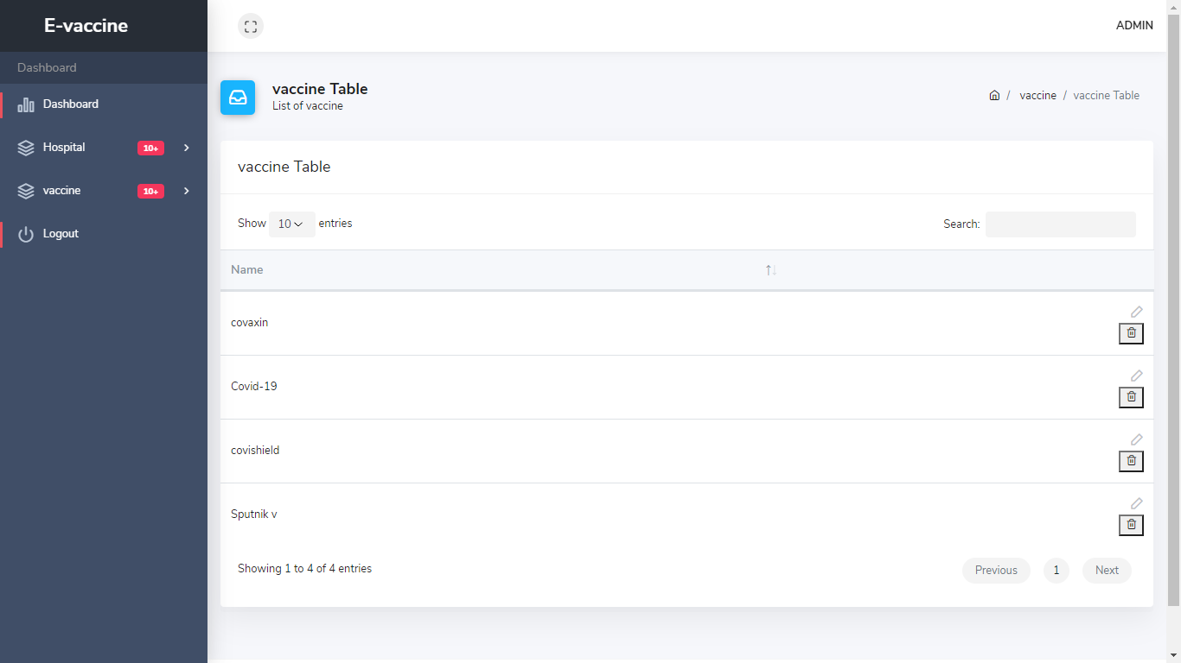

**Update-vaccine** 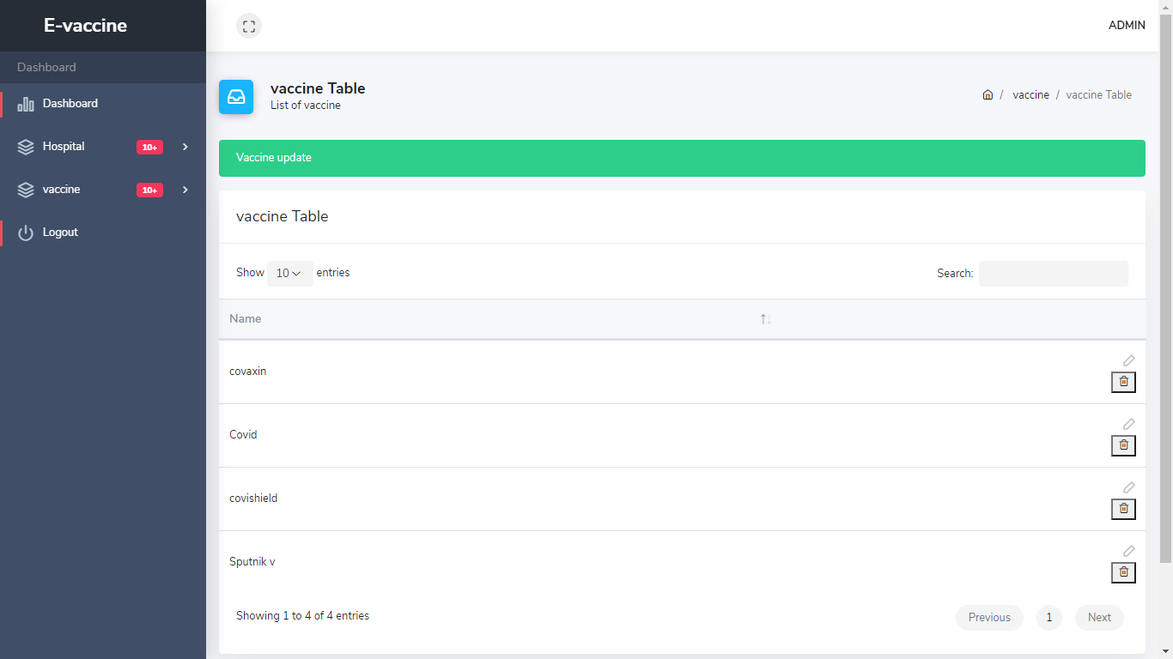

**Delete-Vaccine** 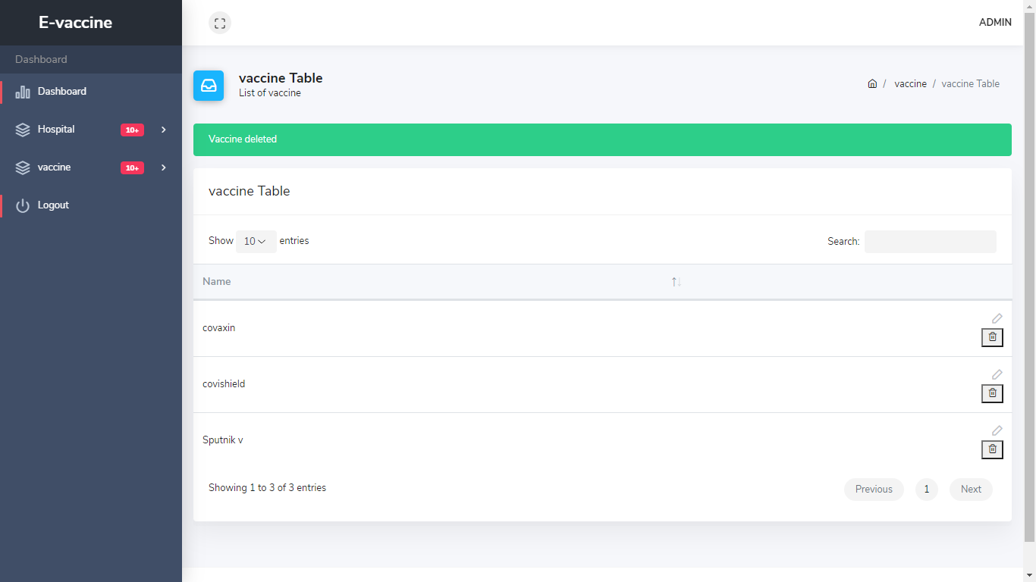

**10. SYSTEM TESTING**

**10.1 Testing and Implementation**

SYSTEM TESTING is a level of testing that validates the complete and fully integrated software product. The purpose of a system test is to evaluate the end-to-end system specifications. Usually, the software is only one element of a larger computer-based system. Ultimately, the software is interfaced with other software/hardware systems. System Testing is actually a series of different tests whose sole purpose is to exercise the full computer-based system.

* **Verification:**

Verification is the process to make sure the product satisfies the conditions imposed at the start of the development phase. In other words, to make sure the product behaves the way we want it to.

* **Validation:**

Validation is the process to make sure the product satisfies the specified requirements at the end of the development phase. In other words, to make sure the product is built as per customer requirements.

**10.2 Testing Methodology**

**10.2.1 Unit Testing**

**What is Unit Testing?**

Unit testing, a testing technique using which individual modules are tested to determine if there are any issues by the developer himself. It is concerned with functional correctness of the standalone modules.

The main aim is to isolate each unit of the system to identify, analyse and fix the defects.

**Unit Testing - Advantages:**

* Reduces Defects in the Newly developed features or reduces bugs when changing the existing functionality.
* Reduces Cost of Testing as defects are captured in very early phase.
* Improves design and allows better refactoring of code.
* Unit Tests, when integrated with build gives the quality of the build as well.

**Unit Testing Life cycle:**



**Unit Testing Techniques:**

1. **Black Box Testing**

**Black Box Testing** is a software testing method in which the functionalities of software applications are tested without having knowledge of internal code structure, implementation details and internal paths. Black Box Testing mainly focuses on input and output of software applications and it is entirely based on software requirements and specifications. It is also known as Behavioural Testing.

1. **White Box Testing**

**White Box Testing** is software testing technique in which internal structure, design and coding of software are tested to verify flow of input-output and to improve design, usability and security. In white box testing, code is visible to testers so it is also called Clear box testing, open box testing, transparent box testing, Code-based testing and Glass box testing.

1. **Grey Box Testing**

**Grey Box Testing** is a software testing technique to test a software product or application with partial knowledge of internal structure of the application. The purpose of grey box testing is to search and identify the defects due to improper code structure or improper use of applications.

**10.3 Testing cases:**

A Test case is usually a simple step that is to perform for its expected result, along with various additional pieces of information.

It is occasionally series of steps but with one expected result. Larger test cases may also contain pre-define states or steps.

The test case steps should be stored at specified place for actual result. These steps can be stored in word processor document, spreadsheet, database or other common responsibility (a place or container to storage.

**FORM -1: REGISTRATION**

|  |  |  |  |
| --- | --- | --- | --- |
| Field Name | Value | Output | Pass/Fail |
| Name | 123 | Only A-Z is Used | Fail |
| Name | Rajan | Rajan | Pass |
| E-mail id | Rajan.ramavat | Wrong Format | Fail |
| E-mail id | [Rajan.ramavat@gmail.com](mailto:Umang.fofaria@gmail.com) | [Rajan.ramavat@gmail.com](mailto:Umang.fofaria@gmail.com) | Pass |
| Password | MgbkjCPQ4nV3z4p | MgbkjCPQ4nV3z4p | Pass |
| Confirm Password | MgbkjCPQ4nV3z4p | MgbkjCPQ4nV3z4p | Pass |

**FORM -2: LOGIN**

|  |  |  |  |
| --- | --- | --- | --- |
| Field Name | Value | Output | Pass/Fail |
| E-mail id | Rajan.ramavat | Wrong Format | Fail |
| E-mail id | [Rajan.ramavat@gmail.com](mailto:Umang.fofaria@gmail.com) | [Rajan.ramavat@gmail.com](mailto:Umang.fofaria@gmail.com) | Pass |
| Password | 12ab | Must be 8-16 Char Long | Fail |
| Password | MgbkjCPQ4nV3z4p | MgbkjCPQ4nV3z4p | Pass |

**FORM -3: ADD Hospital**

|  |  |  |  |
| --- | --- | --- | --- |
| Field Name | Value | Output | Pass/Fail |
| Hospital_Name | AB | Name must be at least 3 characters | Fail |
| Hospital_Name | Shree | Shree | Pass |
| E-mail id | Shree.hospital | Wrong Format | Fail |
| E-mail id | [Shree.hospitat@gmail.com](mailto:Umang.fofaria@gmail.com) | [Shree.hospitat@gmail.com](mailto:Umang.fofaria@gmail.com) | Pass |
| Role | (blank) | required | Fail |
| Role | Hospital | Hospital | Pass |

**11. CONCLUSION**

**11.1 Work Experience:**

The past one and half months have proved to be a great learning experience and have made us aware of the hardships an organization has to deal with while building a website project.

We also came across various methods and conventions that an organization follows in order to develop a project.

Our project guide was always eager to lend a helping hand during the course of developing our project but made sure that we try solving our difficulties by ourselves first and then only ask him for his help thereby made us self-reliant.

He also made sure that we understood every single aspect of the project. We would conclude this by saying that we gained a lot from this training and this knowledge surely will help us in the coming future.

**11.2 Future Enhancement:**

* Add vaccine second dose
* Add valid id proof verification
* Add vaccine ratio Analysis based on gender,city,etc

**11.3 Conclusion:**

In this era of pandemic situation, the website for vaccine Registration booking is very useful for people from different cities as well as for the natives as it makes the efforts easier and faster to find a good vaccine place. This website gives a thorough idea regarding the vaccine slot booking

**12. LEARNING DURING PROJECT WORK**

We have learned Following Technologies during Project Work:

* PHP – Laravel Framework
* Laravel Auth, Laravel UI, FORM,Middleware
* Various Modules of Laravel
* Time management

**13. BIBLIOGRAPHY**

Bibliography means that we have referred while doing project like which web site we were through and which books we have seen in implement this project.

There are many companies website is available online from where we can get our reference. There are many founders in market whose books are available from getting creative reference to create system in proper (right) direction.

**13.1 Online Reference:**

* <https://laravel.com/docs/8.x>
* <https://www.tutorialspoint.com/laravel/index.htm>
* <https://www.w3schools.in/laravel-tutorial/>